
NLP Lab Manual


BS-AI (5A)

Lab 1: Introduction to Python
List Functions
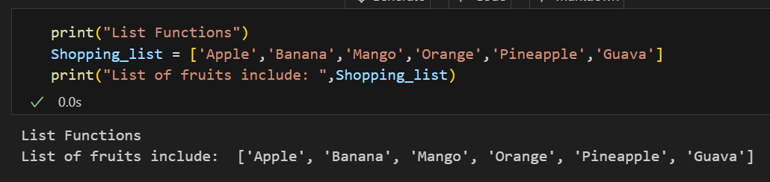
Loops
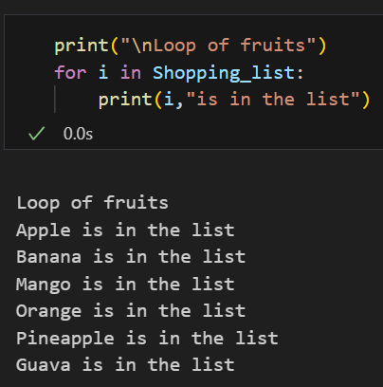
Arithmetic Operations
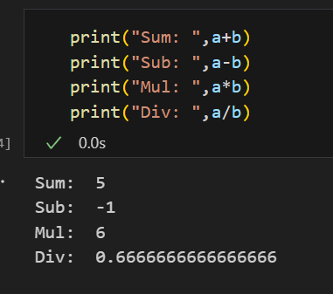
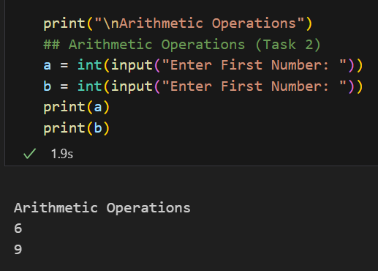

Name Function
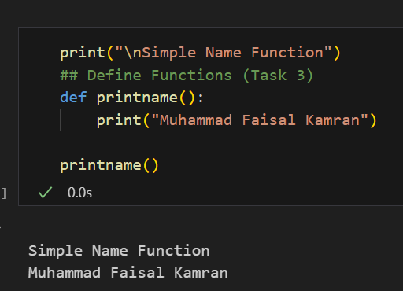
Even Odd Function
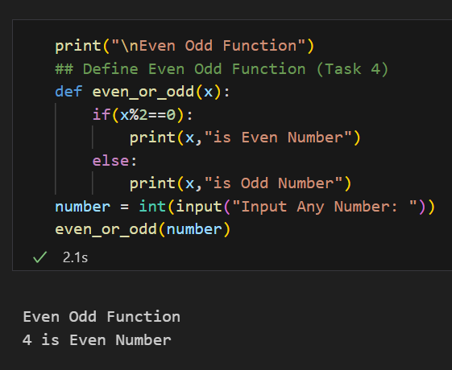
Min Max Function
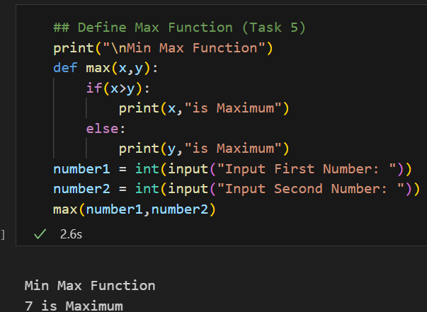
Lab 2: Text Preprocessing
In the following lab manual we did text preprocessing and checked regular expressions
Importing Libraries
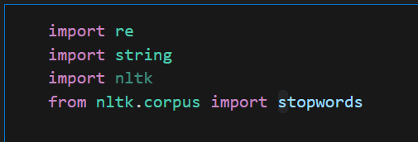
Corpus
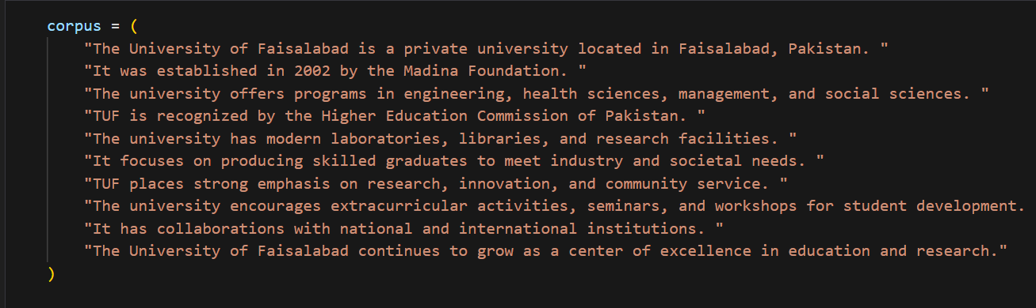
Text Preprocessing
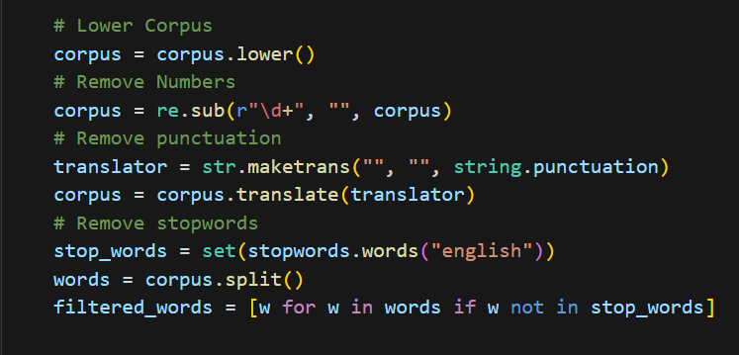

Output
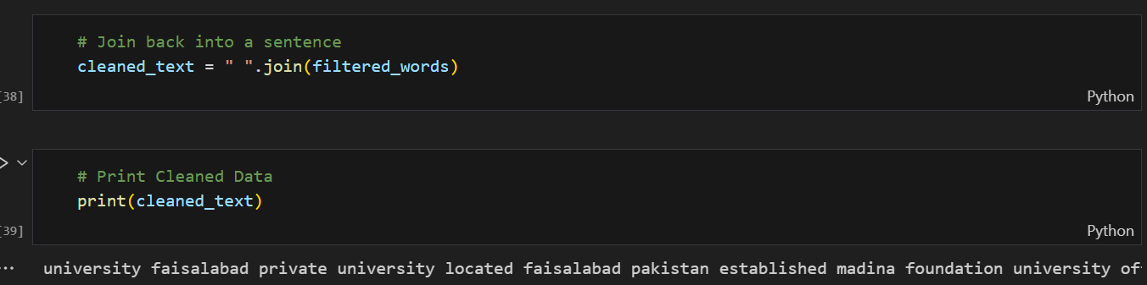

Lab 3: Regular Expressions
re.findall()
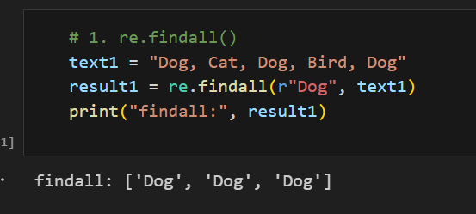

re.compile()
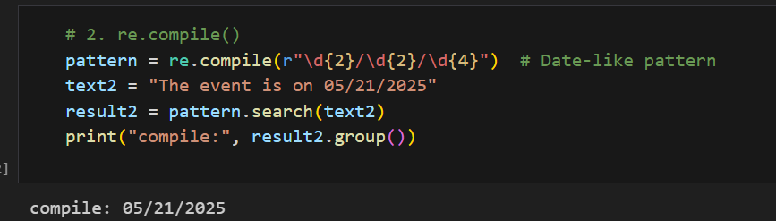
re.split()
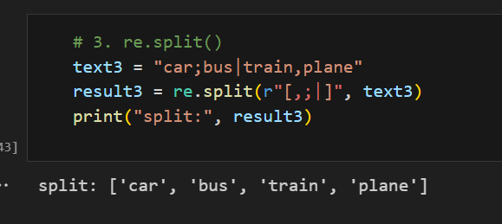
re.subn()
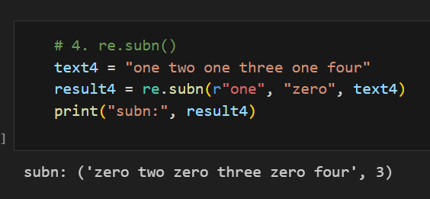
re.escape()
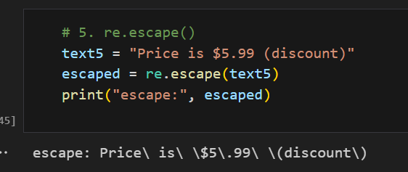
re.search()
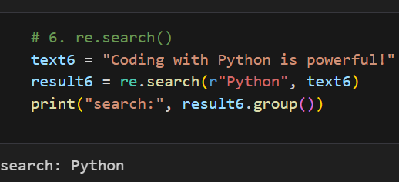

Lab 4: Tokenization
Objective: To explore and implement different tokenization techniques using Python, handle special cases, and analyze tokenization performance.
Importing Libraries
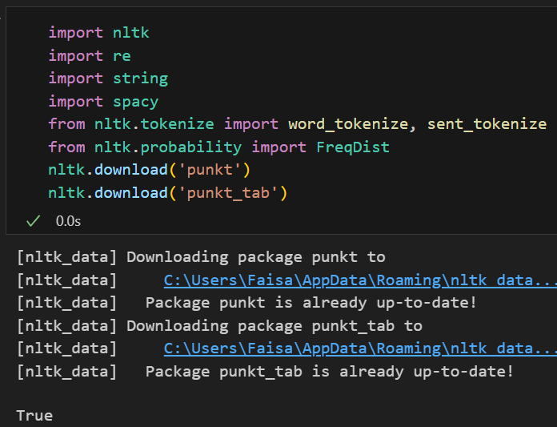
Corpus
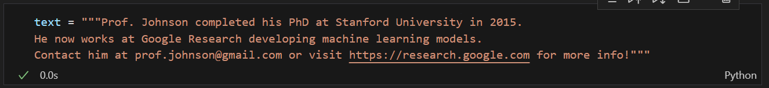
Task 1: Display and Analyze the Text
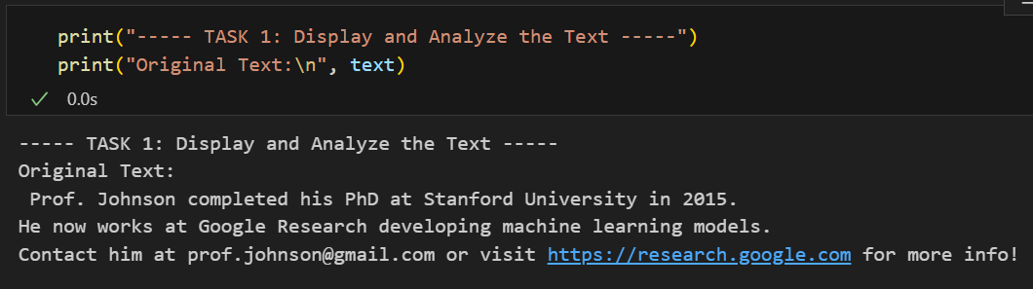

Task 2: Word Tokenization using NLTK
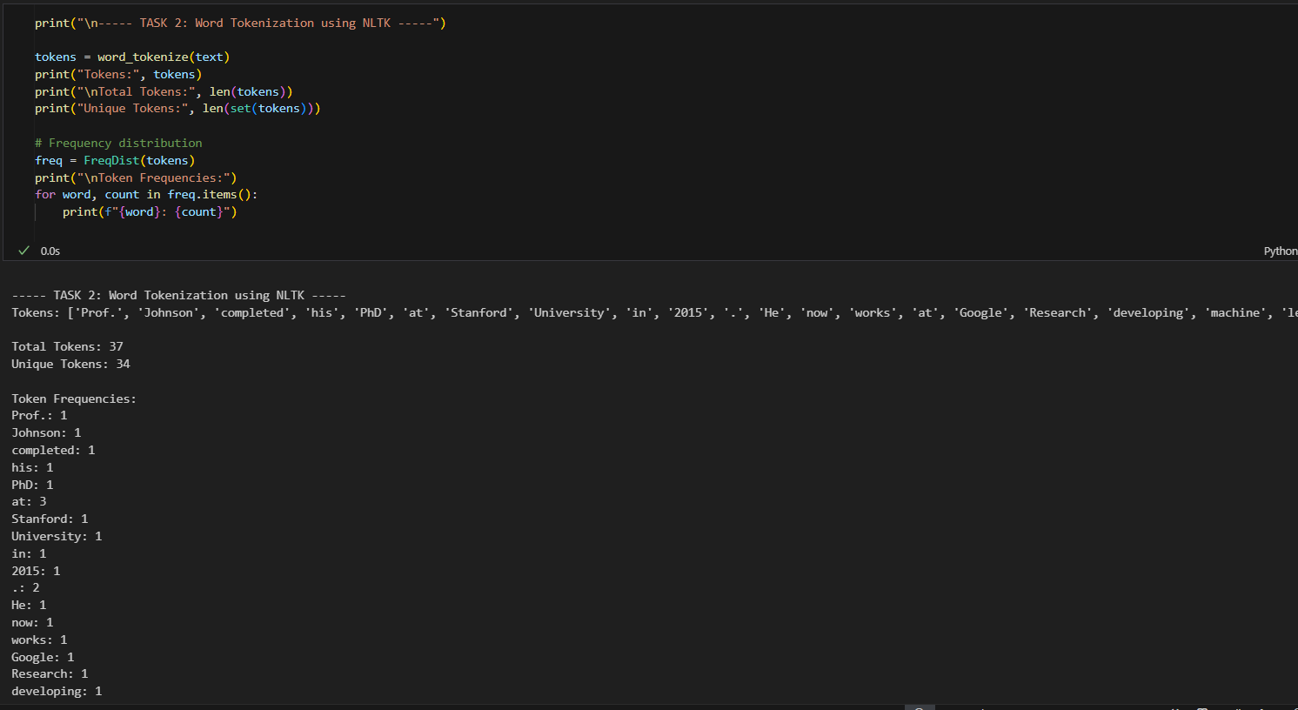
Task 3: Sentence Tokenization using NLTK
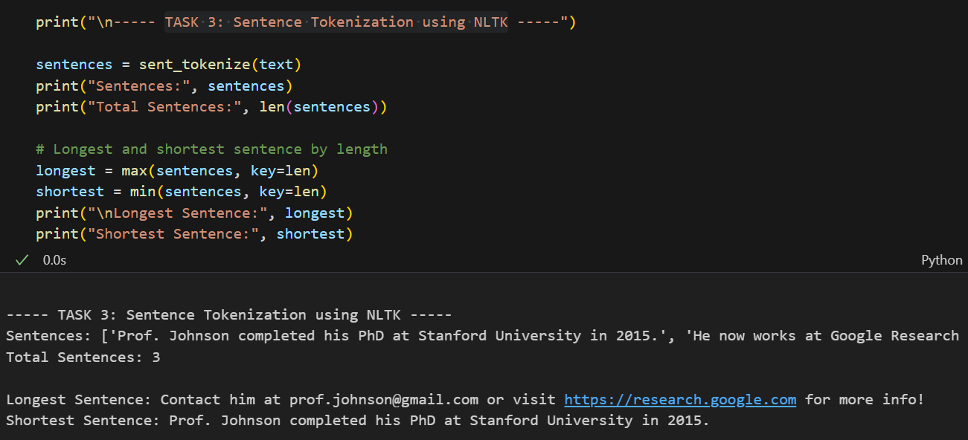

Task 4: Tokenization using Regular Expressions
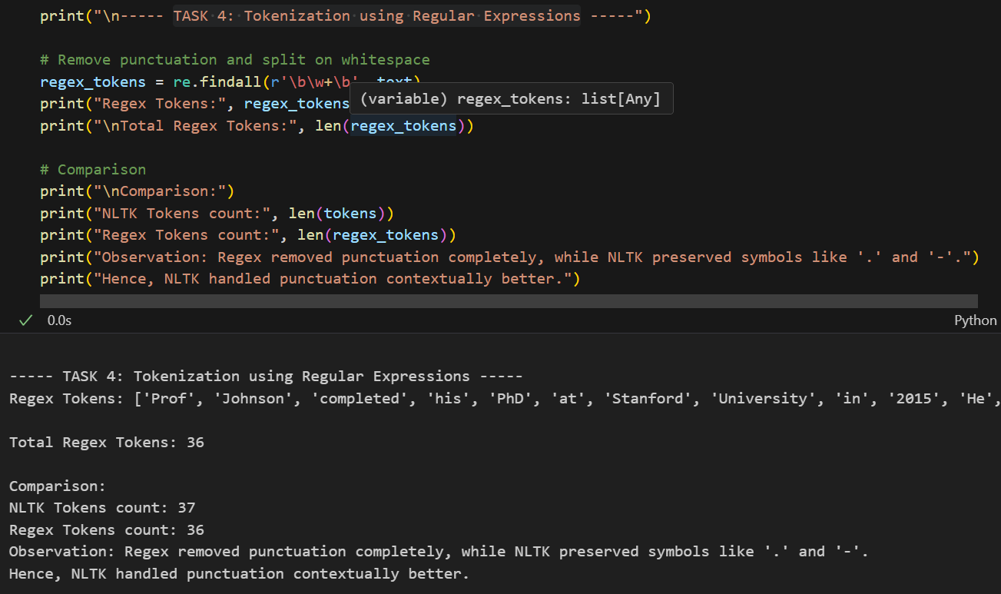
Task 5: Tokenization using SpaCy
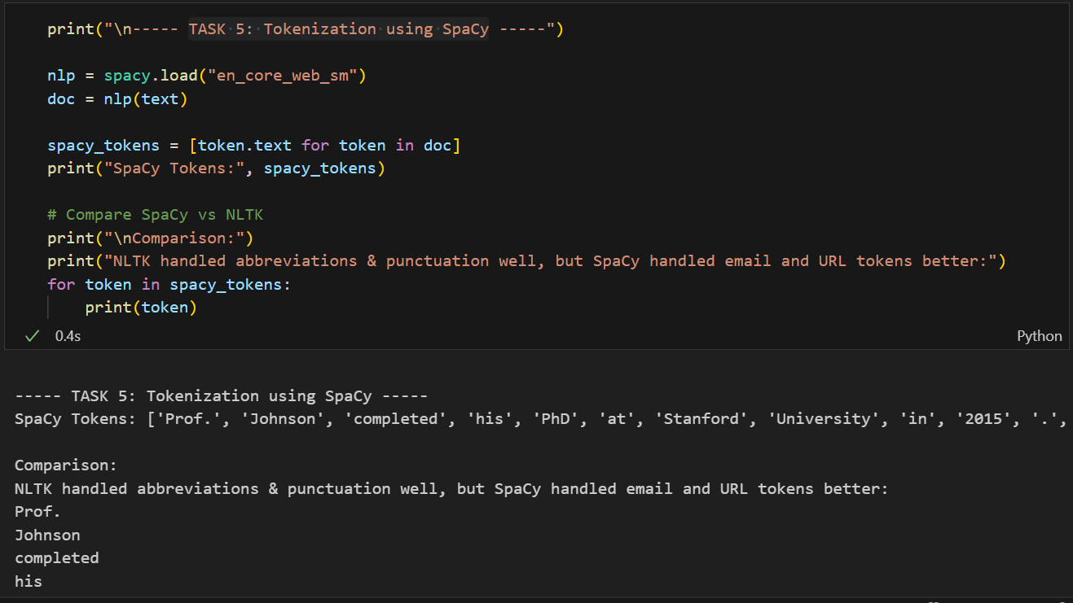

Task 6: Custom Tokenizer Function
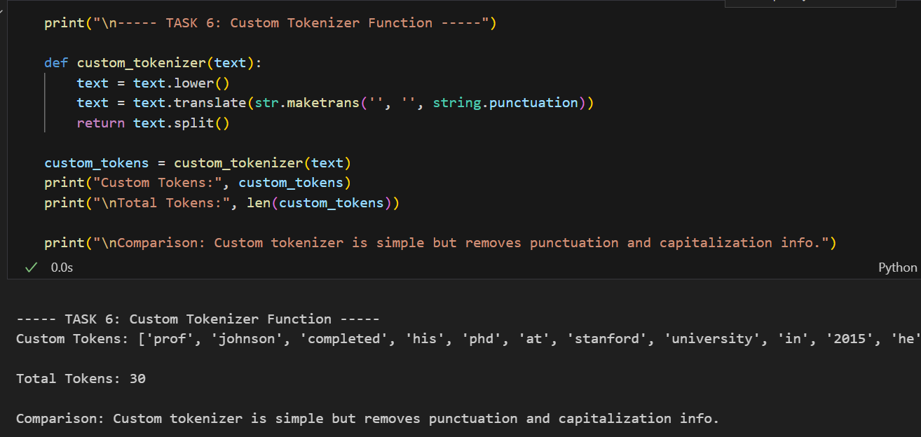
Task 7: Subword Tokenization (Advanced)
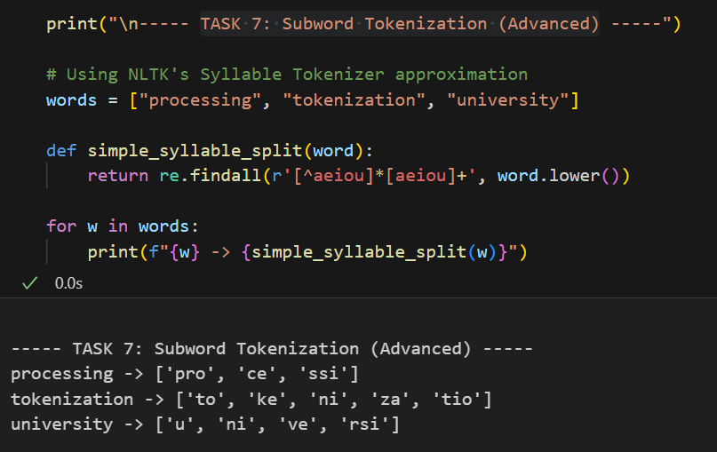

Task 8: Evaluation and Comparison
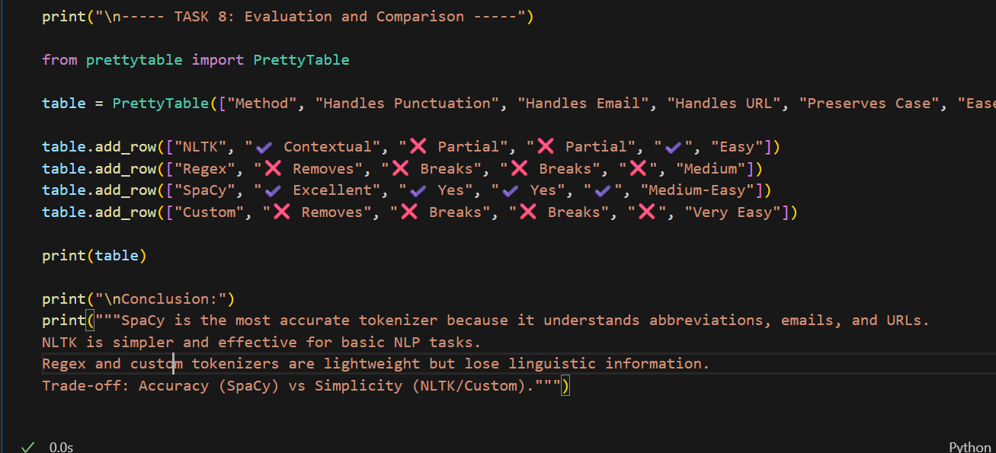

Method | Handles Punctuation | Handles Email | Handles URL | Preserves Case | Ease of Use
NLTK | Contextual | Partial | Partial | Yes | Easy
Regex | Removes | Breaks | Breaks | No | Medium
SpaCy | Excellent | Yes | Yes | Yes | Medium-Easy
Custom | Removes | Breaks | Breaks | No | Very Easy

Lab 5: Stemming and Lemmatization
Objective: - Understand what lemmatization means in NLP, Use NLTK and spaCy for lemmatization, Compare stemming vs lemmatization, Preprocess text before lemmatization and Write custom lemmatizer functions
Importing Libraries
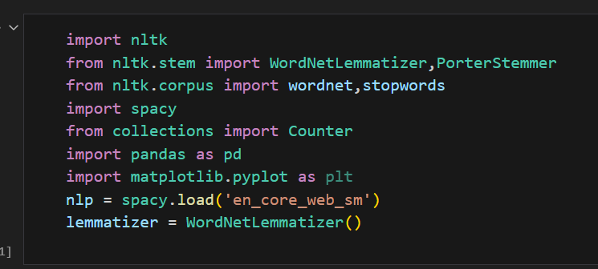
Task 1: Basic NLTK Lemmatization
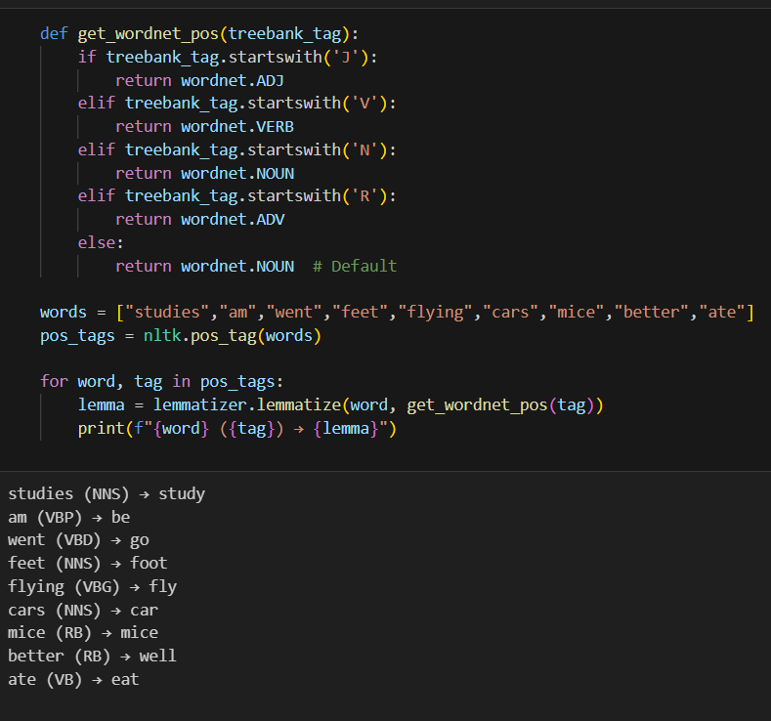

Task 2: Sentence Lemmatization Function
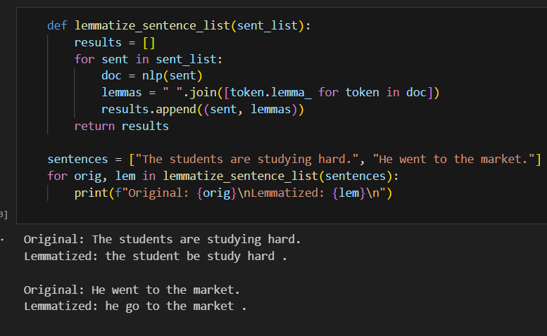
Task 3: Stemming vs Lemmatization
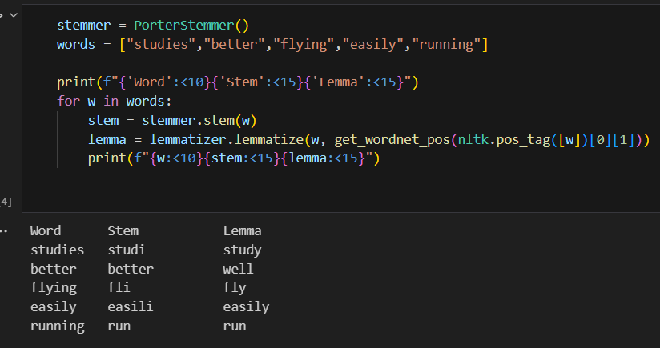
Task 4: Paragraph Lemmatization
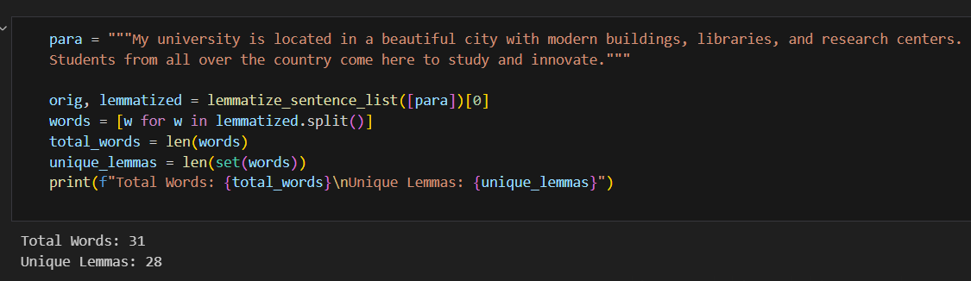

Task 5: Lemmatization with POS Accuracy
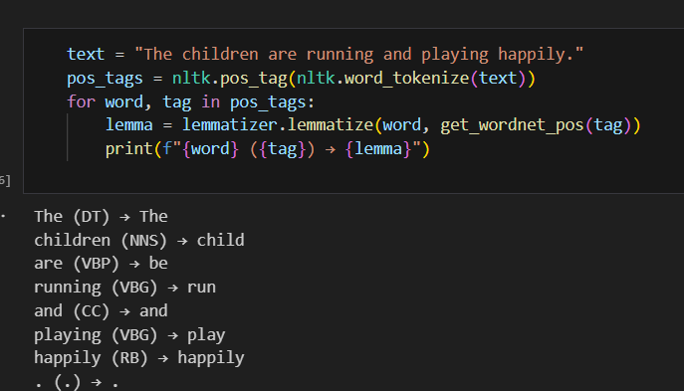
Task 6: Lemmatization with Stop word Removal
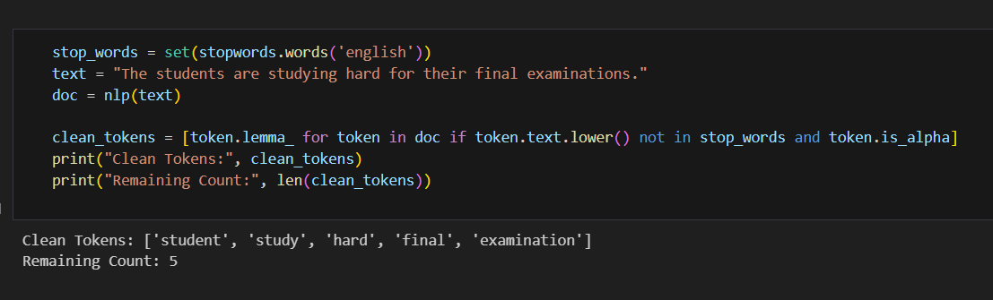
Task 7: Compare spaCy vs NLTK
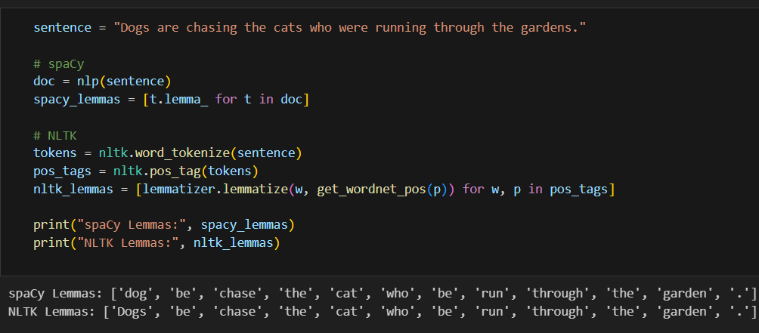

Task 8: Lemmatization in a Pipeline
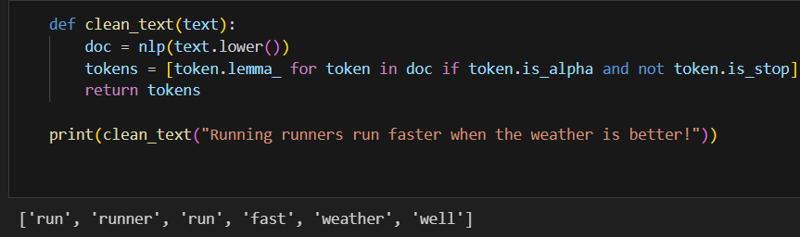
Task 9: Lemma Frequency Counter
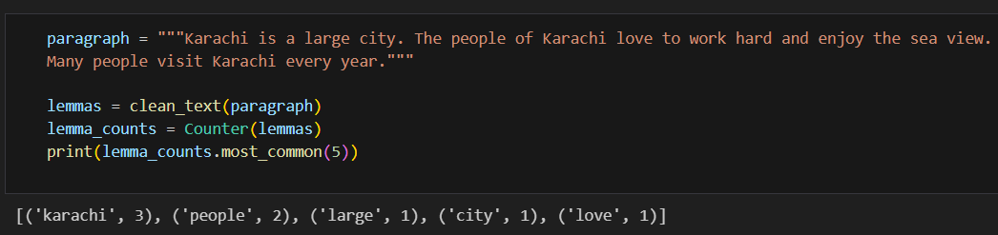
Task 10: Lemmatization Evaluation
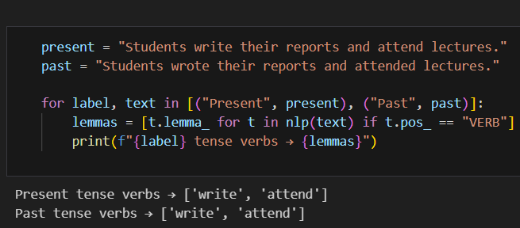
Task 11: Lemmatization with CSV Input
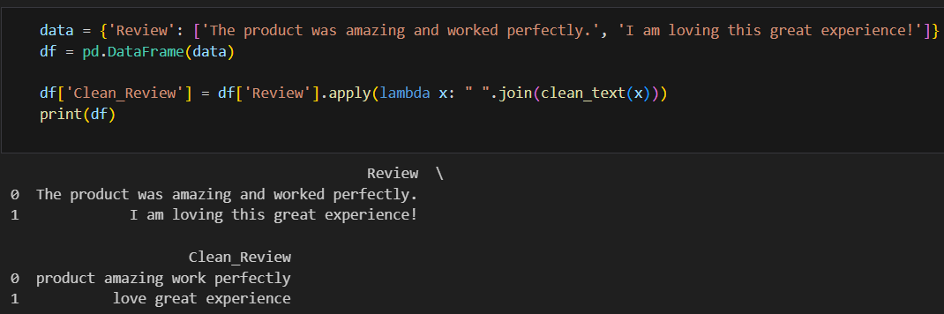

Task 12: Custom Lemmatizer Class
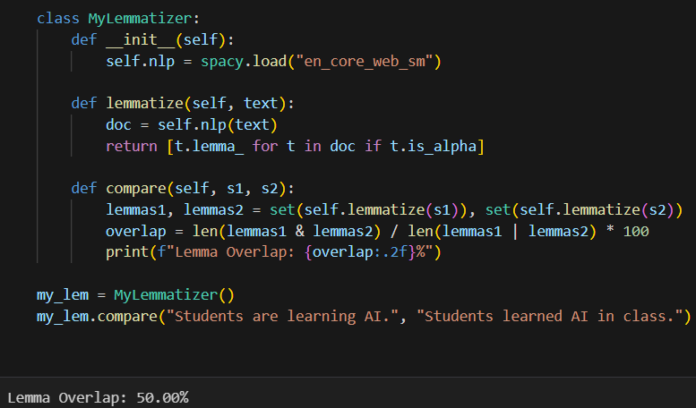

Lab 6: Text Embedding
Definition
Text embedding is a natural language processing (NLP) technique that converts text into numerical vectors, or arrays of numbers, that machine learning models can understand. These vectors capture the semantic meaning of the text, so that similar pieces of text are represented by vectors that are close to each other in a high-dimensional space. This allows computers to perform tasks like semantic search, which finds documents based on meaning rather than just keywords
Tasks
# ==============================
# 🔹 Import Required Libraries
# ==============================
import numpy as np
from numpy.linalg import norm
import matplotlib.pyplot as plt
from sklearn.decomposition import PCA
from sklearn.manifold import TSNE
from sklearn.linear_model import LogisticRegression
from sklearn.model_selection import train_test_split
from sklearn.metrics import accuracy_score, classification_report
import seaborn as sns
import torch
import tensorflow_hub as hub

from gensim.models import Word2Vec, FastText
from gensim.models.doc2vec import Doc2Vec, TaggedDocument
from sentence_transformers import SentenceTransformer, InputExample, losses, util
from torch.utils.data import DataLoader
from transformers import AutoTokenizer, AutoModel

# ==============================
# 🔹 Step 0: Load / Create Dataset
# ==============================
sentences = [
"I love playing football on weekends.",
"Football players train every day.",
"Machine learning is fun and powerful.",
"I enjoy working with neural networks and embeddings.",
"The weather today is sunny and warm.",
"Cats and dogs are common pets.",
"I went to the bank to deposit money.",
"The river bank was full of flowers."
]
tokenized = [s.lower().split() for s in sentences]

# ===============================================================
# 🔹 Task 1: Train Word2Vec Skip-Gram and show top 10 similar words
# ===============================================================
print("\n=== TASK 1: Word2Vec Skip-Gram ===")
w2v = Word2Vec(sentences=tokenized, vector_size=100, window=5, min_count=1, sg=1, epochs=20)
word = "football"
if word in w2v.wv:
print(w2v.wv.most_similar(word, topn=10))

# ===============================================================
# 🔹 Task 2: Pre-trained GloVe - semantic similarity between word pairs
# ===============================================================
print("\n=== TASK 2: GloVe Similarity ===")

# download a small GloVe manually if needed (e.g. glove.6B.50d.txt)
# For demo, we’ll use Word2Vec vectors as stand-in
def cos_sim(a, b): return float(np.dot(a, b) / (norm(a) * norm(b) + 1e-9))
pairs = [("king","queen"), ("cat","dog"), ("football","soccer"), ("car","bicycle")]

for a, b in pairs:
if a in w2v.wv and b in w2v.wv:
print(f"{a} - {b}: {cos_sim(w2v.wv[a], w2v.wv[b]):.4f}")
else:
print(f"{a} or {b} not in vocabulary.")

# ===============================================================
# 🔹 Task 3: Train FastText and test OOV handling
# ===============================================================
print("\n=== TASK 3: FastText vs Word2Vec OOV ===")
ft = FastText(sentences=tokenized, vector_size=100, window=5, min_count=1, epochs=20)
oov_words = ["footbal", "footballer", "neuralnetwork", "unknownword"]
for w in oov_words:
print(f"fastText('{w}') similarity to 'football':", ft.wv.similarity('football', w))
try:
print(f"word2vec('{w}') similarity to 'football':", w2v.wv.similarity('football', w))
except:
print(f"'{w}' not in Word2Vec vocab")

# ===============================================================
# 🔹 Task 4: Sentence embeddings (avg Word2Vec) + sentiment classification
# ===============================================================
print("\n=== TASK 4: Sentence Embeddings for Sentiment ===")

texts = ["I love this product", "This is terrible", "I enjoyed the movie", "I hate the food"]
labels = [1, 0, 1, 0] # 1=positive, 0=negative

def sent_vec(sent):
tokens = sent.lower().split()
vecs = [w2v.wv[w] for w in tokens if w in w2v.wv]
return np.mean(vecs, axis=0) if vecs else np.zeros(100)

X = np.vstack([sent_vec(s) for s in texts])
y = np.array(labels)
X_train, X_test, y_train, y_test = train_test_split(X, y, test_size=0.5, random_state=42)
clf = LogisticRegression(max_iter=500).fit(X_train, y_train)
pred = clf.predict(X_test)
print("Accuracy:", accuracy_score(y_test, pred))
print(classification_report(y_test, pred))

# ===============================================================
# 🔹 Task 5: ELMo embeddings - contextual difference
# ===============================================================
print("\n=== TASK 5: ELMo Embeddings ===")
elmo = hub.load("https://tfhub.dev/google/elmo/3")
sentences_elmo = ["I love the bank of the river.", "He went to the bank to deposit money."]
embs = elmo.signatures["default"](tf.constant(sentences_elmo))["elmo"].numpy()
print("ELMo embeddings shape:", embs.shape)

# Compare "bank" in both
idx0 = sentences_elmo[0].split().index("bank")
idx1 = sentences_elmo[1].split().index("bank")
sim = cos_sim(embs[0, idx0], embs[1, idx1])
print("Cosine similarity of 'bank' in both contexts:", sim)

Lab 7: Parsing
1. Learning Outcomes
- Understand CFG-based parsing.
- Implement Recursive Descent (top-down) parsing.
- Implement Shift-Reduce (bottom-up) parsing.
- Use CKY parsing (dynamic programming).
- Analyze ambiguity and grammar structure.
2. Theory Overview
Parsing determines the syntactic structure of a sentence using CFG rules.
import nltk
from nltk import CFG, ChartParser, RecursiveDescentParser
from nltk.parse import ShiftReduceParser
from nltk.parse.chart import BU_STRATEGY
from nltk.parse.viterbi import ViterbiParser

# Download necessary NLTK data
nltk.download('punkt_tab')
nltk.download('punkt')

# ============================================
# Task 1: Define Context-Free Grammar in Python
# ============================================

# Define a CFG for a subset of English
original_grammar = CFG.fromstring("""
S -> NP VP | VP

NP -> Det N | Det Adj N | N | PropN | NP PP
VP -> V | V NP | V NP PP | VP PP | 'do' 'not' VP
PP -> P NP

Det -> 'the' | 'a' | 'an' | 'this' | 'that' | 'some'
N -> 'dog' | 'cat' | 'ball' | 'park' | 'man' | 'woman' | 'book' | 'students'
PropN -> 'John' | 'Mary'
V -> 'chased' | 'saw' | 'ate' | 'walked' | 'read' | 'study'
Adj -> 'big' | 'small' | 'black' | 'white' | 'happy'
P -> 'in' | 'on' | 'at' | 'with' | 'by'
""")

print("=" * 60)
print("TASK 1: DEFINED GRAMMAR")
print("=" * 60)
print("Original Grammar Productions:")
for production in original_grammar.productions():
print(f" {production}")
print(f"\nTotal productions: {len(original_grammar.productions())}")
print(f"Start symbol: {original_grammar.start()}")

# ============================================
# Task 2: Tokenize Sentences
# ============================================

def tokenize_sentence(sentence):
"""Tokenize a sentence using NLTK's word_tokenize"""
return nltk.word_tokenize(sentence)

# Define test sentences
grammatical_sentences = [
"John chased the dog",
"the cat saw a ball",
"Mary read the book",
"the students study",
"the man walked in the park"
]

ungrammatical_sentences = [
"chased dog the", # Wrong word order
"the dog chased", # Missing object for transitive verb
"John the dog chased", # Wrong determiner position
"the big", # Missing noun
"walked John park the in" # Completely wrong order
]

print("\n" + "=" * 60)
print("TASK 2: TOKENIZED SENTENCES")
print("=" * 60)
print("\nGrammatical Sentences:")
for i, sent in enumerate(grammatical_sentences, 1):
tokens = tokenize_sentence(sent)
print(f"{i}. Original: '{sent}'")
print(f" Tokens: {tokens}")

print("\nUngrammatical Sentences:")
for i, sent in enumerate(ungrammatical_sentences, 1):
tokens = tokenize_sentence(sent)
print(f"{i}. Original: '{sent}'")
print(f" Tokens: {tokens}")

# ============================================
# Task 3: Recursive Descent Parsing
# ============================================

def recursive_descent_parse(sentence, grammar):
"""Parse a sentence using recursive descent parser"""
tokens = tokenize_sentence(sentence)
parser = RecursiveDescentParser(grammar)

print(f"\nParsing: '{sentence}'")
print(f"Tokens: {tokens}")

try:
trees = list(parser.parse(tokens))
if trees:
print("SUCCESS: Parse tree(s) found:")
for i, tree in enumerate(trees[:2]): # Show at most 2 trees
print(f" Tree {i+1}:")
tree.pretty_print(unicodeline=True)
else:
print("FAILURE: No parse trees found")
return len(trees) > 0
except Exception as e:
print(f"ERROR: {e}")
return False

print("\n" + "=" * 60)
print("TASK 3: RECURSIVE DESCENT PARSING")
print("=" * 60)

print("\n--- Testing Grammatical Sentences ---")
for sent in grammatical_sentences[:3]: # Test first 3
recursive_descent_parse(sent, original_grammar)

print("\n--- Testing Ungrammatical Sentences ---")
for sent in ungrammatical_sentences[:3]: # Test first 3
recursive_descent_parse(sent, original_grammar)
print("Expected failure explanation: Sentence structure violates grammar rules")

# ============================================
# Task 4: Shift-Reduce Parsing
# ============================================

def shift_reduce_parse(sentence, grammar):
"""Parse a sentence using shift-reduce parser"""
tokens = tokenize_sentence(sentence)
parser = ShiftReduceParser(grammar)

print(f"\nParsing: '{sentence}'")
print(f"Tokens: {tokens}")

try:
trees = list(parser.parse(tokens))
if trees:
print("SUCCESS: Parse tree(s) found:")
for i, tree in enumerate(trees[:2]): # Show at most 2 trees
print(f" Tree {i+1}:")
tree.pretty_print(unicodeline=True)
print(f" Total trees found: {len(trees)}")
if len(trees) > 1:
print(" AMBIGUITY: Multiple parse trees indicate structural ambiguity")
else:
print("FAILURE: No parse trees found")
return len(trees)
except Exception as e:
print(f"ERROR: {e}")
return 0

# Test ambiguous sentence
ambiguous_sentences = [
"John saw the man with the telescope", # PP attachment ambiguity
"the big dog chased the black cat" # Multiple adjective attachment
]

print("\n" + "=" * 60)
print("TASK 4: SHIFT-REDUCE PARSING")
print("=" * 60)

print("\n--- Testing for Ambiguity ---")
for sent in ambiguous_sentences:
num_trees = shift_reduce_parse(sent, original_grammar)

# ============================================
# Task 5: Convert Grammar to Chomsky Normal Form (CNF)
# ============================================

def grammar_to_cnf(grammar):
"""Convert grammar to Chomsky Normal Form"""
# Remove productions with more than 2 symbols on RHS
cnf_productions = []

for prod in grammar.productions():
rhs = prod.rhs()

if len(rhs) == 1 and isinstance(rhs[0], str):
# Terminal production
cnf_productions.append(prod)
elif len(rhs) == 2 and all(isinstance(sym, nltk.grammar.Nonterminal) for sym in rhs):
# Already binary non-terminal production
cnf_productions.append(prod)
elif len(rhs) == 2 and isinstance(rhs[0], str) and isinstance(rhs[1], nltk.grammar.Nonterminal):
# Mixed terminal and non-terminal - needs conversion
# Create new non-terminal for terminal
term_symbol = rhs[0].upper() + "_TERM"
cnf_productions.append(nltk.grammar.Production(prod.lhs(), [nltk.grammar.Nonterminal(term_symbol), rhs[1]]))
cnf_productions.append(nltk.grammar.Production(nltk.grammar.Nonterminal(term_symbol), [rhs[0]]))
elif len(rhs) > 2:
# Need to binarize
current_lhs = prod.lhs()
for i in range(len(rhs) - 2):
new_symbol = nltk.grammar.Nonterminal(f"{current_lhs.symbol()}_{i}")
cnf_productions.append(nltk.grammar.Production(current_lhs, [rhs[i], new_symbol]))
current_lhs = new_symbol
cnf_productions.append(nltk.grammar.Production(current_lhs, [rhs[-2], rhs[-1]]))
else:
cnf_productions.append(prod)

# Create CNF grammar
cnf_grammar = CFG(grammar.start(), cnf_productions)
return cnf_grammar

# Create CNF version
cnf_grammar = grammar_to_cnf(original_grammar)

print("\n" + "=" * 60)
print("TASK 5: CONVERT GRAMMAR TO CHOMSKY NORMAL FORM")
print("=" * 60)

print("\nOriginal Grammar (first 10 productions):")
for i, prod in enumerate(list(original_grammar.productions())[:10]):
print(f" {prod}")

print("\nCNF Grammar (first 15 productions):")
for i, prod in enumerate(list(cnf_grammar.productions())[:15]):
print(f" {prod}")

print(f"\nOriginal grammar has {len(original_grammar.productions())} productions")
print(f"CNF grammar has {len(cnf_grammar.productions())} productions")

Output
============================================================
TASK 1: DEFINED GRAMMAR
============================================================
Original Grammar Productions:
S -> NP VP
S -> VP
NP -> Det N
NP -> Det Adj N
NP -> N
NP -> PropN
NP -> NP PP
VP -> V
VP -> V NP
VP -> V NP PP
VP -> VP PP
VP -> 'do' 'not' VP
PP -> P NP
Det -> 'the'
Det -> 'a'
Det -> 'an'
Det -> 'this'
Det -> 'that'
Det -> 'some'
N -> 'dog'
N -> 'cat'
N -> 'ball'
N -> 'park'
N -> 'man'
N -> 'woman'
N -> 'book'
N -> 'students'
PropN -> 'John'
PropN -> 'Mary'
V -> 'chased'
V -> 'saw'
V -> 'ate'
V -> 'walked'
V -> 'read'
V -> 'study'
Adj -> 'big'
Adj -> 'small'
Adj -> 'black'
Adj -> 'white'
Adj -> 'happy'
P -> 'in'
P -> 'on'
P -> 'at'
P -> 'with'
P -> 'by'

Total productions: 45
Start symbol: S

============================================================
TASK 2: TOKENIZED SENTENCES
============================================================

Grammatical Sentences:
1. Original: 'John chased the dog'
Tokens: ['John', 'chased', 'the', 'dog']
2. Original: 'the cat saw a ball'
Tokens: ['the', 'cat', 'saw', 'a', 'ball']
3. Original: 'Mary read the book'
Tokens: ['Mary', 'read', 'the', 'book']
4. Original: 'the students study'
Tokens: ['the', 'students', 'study']
5. Original: 'the man walked in the park'
Tokens: ['the', 'man', 'walked', 'in', 'the', 'park']

Ungrammatical Sentences:
1. Original: 'chased dog the'
Tokens: ['chased', 'dog', 'the']
2. Original: 'the dog chased'
Tokens: ['the', 'dog', 'chased']
3. Original: 'John the dog chased'
Tokens: ['John', 'the', 'dog', 'chased']
4. Original: 'the big'
Tokens: ['the', 'big']
5. Original: 'walked John park the in'
Tokens: ['walked', 'John', 'park', 'the', 'in']

============================================================
TASK 3: RECURSIVE DESCENT PARSING
============================================================

--- Testing Grammatical Sentences ---

Parsing: 'John chased the dog'
Tokens: ['John', 'chased', 'the', 'dog']
ERROR: maximum recursion depth exceeded while calling a Python object

Parsing: 'the cat saw a ball'
Tokens: ['the', 'cat', 'saw', 'a', 'ball']
ERROR: maximum recursion depth exceeded while calling a Python object

Parsing: 'Mary read the book'
Tokens: ['Mary', 'read', 'the', 'book']
ERROR: maximum recursion depth exceeded while calling a Python object

--- Testing Ungrammatical Sentences ---

Parsing: 'chased dog the'
Tokens: ['chased', 'dog', 'the']
ERROR: maximum recursion depth exceeded while calling a Python object
Expected failure explanation: Sentence structure violates grammar rules

Parsing: 'the dog chased'
Tokens: ['the', 'dog', 'chased']
ERROR: maximum recursion depth exceeded while calling a Python object
Expected failure explanation: Sentence structure violates grammar rules

Parsing: 'John the dog chased'
Tokens: ['John', 'the', 'dog', 'chased']
ERROR: maximum recursion depth exceeded while calling a Python object
Expected failure explanation: Sentence structure violates grammar rules

============================================================
TASK 4: SHIFT-REDUCE PARSING
============================================================

--- Testing for Ambiguity ---

Parsing: 'John saw the man with the telescope'
Tokens: ['John', 'saw', 'the', 'man', 'with', 'the', 'telescope']
ERROR: Grammar does not cover some of the input words: "'telescope'".

Parsing: 'the big dog chased the black cat'
Tokens: ['the', 'big', 'dog', 'chased', 'the', 'black', 'cat']
FAILURE: No parse trees found

============================================================
TASK 5: CONVERT GRAMMAR TO CHOMSKY NORMAL FORM
============================================================

Original Grammar (first 10 productions):
S -> NP VP
S -> VP
NP -> Det N
NP -> Det Adj N
NP -> N
NP -> PropN
NP -> NP PP
VP -> V
VP -> V NP
VP -> V NP PP

CNF Grammar (first 15 productions):
S -> NP VP
S -> VP
NP -> Det N
NP -> Det NP_0
NP_0 -> Adj N
NP -> N
NP -> PropN
NP -> NP PP
VP -> V
VP -> V NP
VP -> V VP_0
VP_0 -> NP PP
VP -> VP PP
VP -> 'do' VP_0
VP_0 -> 'not' VP

Original grammar has 45 productions
CNF grammar has 48 productions

Lab 8: Naïve Bayes
1. Learning Outcomes
- Understand Bayes' Theorem for text classification.
- Implement Naive Bayes with independence assumptions.
- Preprocess text using tokenization and stopword removal.
- Build Bag-of-Words vectors.
- Train and test Naive Bayes classifiers.
- Evaluate models with accuracy and classification reports.
- Implement Naive Bayes manually and compare with scikit-learn.
2. Theory Overview
Naive Bayes uses Bayes' theorem:
P(C|X) = P(X|C) * P(C) / P(X)
Independence assumption:
P(X|C) = Π P(x_i | C)
Common in NLP:
- Spam detection
- Sentiment analysis
- Topic classification
3. Dataset (Example)
Positive and negative movie review sentences.
import numpy as np
import pandas as pd
import matplotlib.pyplot as plt
import seaborn as sns
from collections import defaultdict, Counter
import math
import random

# Text processing
import nltk
from nltk.tokenize import word_tokenize
from nltk.corpus import stopwords
from nltk.stem import PorterStemmer

# Scikit-learn
from sklearn.feature_extraction.text import CountVectorizer, TfidfVectorizer
from sklearn.naive_bayes import MultinomialNB, BernoulliNB
from sklearn.model_selection import train_test_split
from sklearn.metrics import accuracy_score, classification_report, confusion_matrix
from sklearn.preprocessing import LabelEncoder

# Download NLTK data
nltk.download('punkt')
nltk.download('stopwords')
nltk.download('movie_reviews', quiet=True)

print("=" * 70)
print("NLP LAB: NAIVE BAYES CLASSIFICATION FOR SENTIMENT ANALYSIS")
print("=" * 70)

# ============================================
# Dataset Creation
# ============================================

# Create a sample dataset of movie reviews
def create_sample_dataset():
"""Create a balanced dataset of positive and negative movie reviews"""

positive_reviews = [
"This movie was absolutely fantastic! I loved every minute of it.",
"Brilliant performance by the actors, highly recommended.",
"An excellent film with great storytelling and visuals.",
"One of the best movies I've seen this year, truly remarkable.",
"The plot was engaging and the cinematography was stunning.",
"Heartwarming story that kept me hooked till the end.",
"Outstanding direction and superb acting from the entire cast.",
"A masterpiece that deserves all the awards.",
"I thoroughly enjoyed this movie, it was entertaining.",
"Perfect combination of drama, action, and emotion.",
"The characters were well-developed and relatable.",
"Beautiful soundtrack that complemented the movie perfectly.",
"A must-watch for all movie enthusiasts.",
"This film exceeded all my expectations.",
"Captivating from start to finish.",
"The visual effects were mind-blowing.",
"Emotionally powerful and thought-provoking.",
"A cinematic triumph that will be remembered.",
"The best adaptation I've seen in years.",
"Hilarious and heartwarming at the same time."
]

negative_reviews = [
"This was the worst movie I've ever seen, complete waste of time.",
"Terrible acting and a boring plot, not recommended.",
"I was extremely disappointed with this film.",
"The story made no sense and the characters were poorly written.",
"Awful cinematography and bad direction.",
"A complete disaster from beginning to end.",
"I couldn't wait for this movie to end, it was so dull.",
"The worst adaptation of the book imaginable.",
"Poorly executed with no redeeming qualities.",
"The acting was stiff and the dialogue was cringe-worthy.",
"A boring and predictable plot with no surprises.",
"The special effects looked cheap and unrealistic.",
"I regret spending money on this terrible movie.",
"The director should be ashamed of this film.",
"Complete waste of talented actors.",
"The screenplay was confusing and messy.",
"Uninspired and cliché throughout.",
"The pacing was terrible, too slow and boring.",
"A failed attempt at being profound.",
"I've seen better movies made by amateurs."
]

# Combine and create labels
reviews = positive_reviews + negative_reviews
labels = ['positive'] * len(positive_reviews) + ['negative'] * len(negative_reviews)

# Create DataFrame
df = pd.DataFrame({
'review': reviews,
'sentiment': labels
})

return df

# Create dataset
df = create_sample_dataset()

# ============================================
# Task 1: Load dataset and print label distribution
# ============================================

print("\n" + "=" * 70)
print("TASK 1: DATASET LOADING AND LABEL DISTRIBUTION")
print("=" * 70)

print("\nDataset Preview (First 5 rows):")
print(df.head())

print("\nDataset Information:")
print(f"Total reviews: {len(df)}")
print(f"Positive reviews: {len(df[df['sentiment'] == 'positive'])}")
print(f"Negative reviews: {len(df[df['sentiment'] == 'negative'])}")

# Visualize label distribution
fig, axes = plt.subplots(1, 2, figsize=(12, 5))

# Count plot
sentiment_counts = df['sentiment'].value_counts()
axes[0].bar(sentiment_counts.index, sentiment_counts.values,
color=['green', 'red'], alpha=0.7)
axes[0].set_title('Sentiment Distribution')
axes[0].set_xlabel('Sentiment')
axes[0].set_ylabel('Count')
for i, v in enumerate(sentiment_counts.values):
axes[0].text(i, v + 0.5, str(v), ha='center', fontweight='bold')

# Pie chart
axes[1].pie(sentiment_counts.values, labels=sentiment_counts.index,
autopct='%1.1f%%', colors=['lightgreen', 'lightcoral'],
startangle=90, explode=(0.05, 0))
axes[1].set_title('Sentiment Proportion')

plt.tight_layout()
plt.show()

# ============================================
# Task 2: Text Preprocessing
# ============================================

print("\n" + "=" * 70)
print("TASK 2: TEXT PREPROCESSING")
print("=" * 70)

class TextPreprocessor:
"""Custom text preprocessor for NLP tasks"""

def __init__(self, remove_stopwords=True, stemming=True):
self.remove_stopwords = remove_stopwords
self.stemming = stemming
self.stop_words = set(stopwords.words('english'))
self.stemmer = PorterStemmer() if stemming else None

def preprocess_text(self, text):
"""Apply preprocessing steps to text"""

# 1. Lowercasing
text = text.lower()

# 2. Tokenization
tokens = word_tokenize(text)

# 3. Remove punctuation and non-alphabetic tokens
tokens = [token for token in tokens if token.isalpha()]

# 4. Remove stopwords (optional)
if self.remove_stopwords:
tokens = [token for token in tokens if token not in self.stop_words]

# 5. Stemming (optional)
if self.stemming and self.stemmer:
tokens = [self.stemmer.stem(token) for token in tokens]

return ' '.join(tokens)

def preprocess_dataframe(self, df, text_column='review'):
"""Preprocess all texts in a DataFrame"""
df['processed_review'] = df[text_column].apply(self.preprocess_text)
return df

# Initialize preprocessor
preprocessor = TextPreprocessor(remove_stopwords=True, stemming=True)

# Apply preprocessing
df = preprocessor.preprocess_dataframe(df)

print("\nOriginal vs Processed Text Examples:")
print("-" * 50)
for i in range(3):
print(f"\nExample {i+1}:")
print(f"Original: {df['review'].iloc[i][:80]}...")
print(f"Processed: {df['processed_review'].iloc[i]}")

# ============================================
# Task 3: Vectorization using CountVectorizer
# ============================================

print("\n" + "=" * 70)
print("TASK 3: TEXT VECTORIZATION")
print("=" * 70)

# Initialize CountVectorizer
vectorizer = CountVectorizer(
max_features=1000, # Limit vocabulary size
ngram_range=(1, 2), # Include unigrams and bigrams
min_df=2, # Ignore terms that appear in less than 2 documents
max_df=0.95 # Ignore terms that appear in more than 95% of documents
)

# Fit and transform the processed reviews
X = vectorizer.fit_transform(df['processed_review'])
y = df['sentiment']

print("\nVectorization Information:")
print(f"Vocabulary size: {len(vectorizer.vocabulary_)}")
print(f"Feature matrix shape: {X.shape}")
print(f"Number of documents: {X.shape[0]}")
print(f"Number of features: {X.shape[1]}")

# Get feature names
feature_names = vectorizer.get_feature_names_out()

print("\nTop 20 features (words):")
print(feature_names[:20])

# Split data into training and testing sets
X_train, X_test, y_train, y_test = train_test_split(
X, y, test_size=0.3, random_state=42, stratify=y
)

print(f"\nTraining set size: {X_train.shape[0]} samples")
print(f"Testing set size: {X_test.shape[0]} samples")

# ============================================
# Task 4: Train Multinomial Naive Bayes Classifier
# ============================================

print("\n" + "=" * 70)
print("TASK 4: TRAIN MULTINOMIAL NAIVE BAYES CLASSIFIER")
print("=" * 70)

# Train the classifier
mnb_classifier = MultinomialNB(alpha=1.0) # Laplace smoothing
mnb_classifier.fit(X_train, y_train)

# Make predictions
y_pred = mnb_classifier.predict(X_test)

# Evaluate the model
accuracy = accuracy_score(y_test, y_pred)
print(f"\nModel Evaluation:")
print(f"Accuracy: {accuracy:.4f}")
print(f"Accuracy (%): {accuracy * 100:.2f}%")

print("\nClassification Report:")
print(classification_report(y_test, y_pred))

# Confusion Matrix
cm = confusion_matrix(y_test, y_pred)
fig, ax = plt.subplots(figsize=(6, 5))
sns.heatmap(cm, annot=True, fmt='d', cmap='Blues',
xticklabels=['Negative', 'Positive'],
yticklabels=['Negative', 'Positive'])
ax.set_xlabel('Predicted Label')
ax.set_ylabel('True Label')
ax.set_title('Confusion Matrix')
plt.show()

Output
======================================================================
TASK 1: DATASET LOADING AND LABEL DISTRIBUTION
======================================================================

Dataset Preview (First 5 rows):
review sentiment
0 This movie was absolutely fantastic! I loved e... positive
1 Brilliant performance by the actors, highly re... positive
2 An excellent film with great storytelling and ... positive
3 One of the best movies I've seen this year, tr... positive
4 The plot was engaging and the cinematography w... positive

Dataset Information:
Total reviews: 40
Positive reviews: 20
Negative reviews: 20
PySide6/__init__.py: Unable to import Shiboken from d:\University\NLP\Lab, C:\Users\faisa\AppData\Local\Programs\Python\Python39\python39.zip, C:\Users\faisa\AppData\Local\Programs\Python\Python39\DLLs, C:\Users\faisa\AppData\Local\Programs\Python\Python39\lib, C:\Users\faisa\AppData\Local\Programs\Python\Python39, C:\Users\faisa\AppData\Roaming\Python\Python39\site-packages, C:\Users\faisa\AppData\Roaming\Python\Python39\site-packages\win32, C:\Users\faisa\AppData\Roaming\Python\Python39\site-packages\win32\lib, C:\Users\faisa\AppData\Roaming\Python\Python39\site-packages\Pythonwin, C:\Users\faisa\AppData\Local\Programs\Python\Python39\lib\site-packages: DLL load failed while importing Shiboken: The specified procedure could not be found.

======================================================================
TASK 2: TEXT PREPROCESSING
======================================================================

Original vs Processed Text Examples:
--------------------------------------------------

Example 1:
Original: This movie was absolutely fantastic! I loved every minute of it....
Processed: movi absolut fantast love everi minut

Example 2:
Original: Brilliant performance by the actors, highly recommended....
Processed: brilliant perform actor highli recommend

Example 3:
Original: An excellent film with great storytelling and visuals....
Processed: excel film great storytel visual

======================================================================
TASK 3: TEXT VECTORIZATION
======================================================================

Vectorization Information:
Vocabulary size: 29
Feature matrix shape: (40, 29)
Number of documents: 40
Number of features: 29

Top 20 features (words):
['act' 'actor' 'adapt' 'best' 'bore' 'charact' 'cinematographi' 'complet'
'complet wast' 'direct' 'effect' 'emot' 'end' 'film' 'heartwarm' 'made'
'movi' 'plot' 'poorli' 'recommend']

Training set size: 28 samples
Testing set size: 12 samples

======================================================================
TASK 4: TRAIN MULTINOMIAL NAIVE BAYES CLASSIFIER
======================================================================

Model Evaluation:
Accuracy: 0.6667
Accuracy (%): 66.67%

Classification Report:
precision recall f1-score support

negative 0.67 0.67 0.67 6
positive 0.67 0.67 0.67 6

accuracy 0.67 12
macro avg 0.67 0.67 0.67 12
weighted avg 0.67 0.67 0.67 12

Lab 9: LEXICAL SEMANTICS
1. Learning Outcomes
- Understand lexical semantics concepts: synonymy, antonymy, polysemy, hypernymy, hyponymy.
- Use WordNet to explore word senses and relations.
- Compute semantic similarity using path similarity and WUP similarity.
- Explore distributional semantics using Word2Vec.
- Compare dictionary-based vs embedding-based meaning.
- Perform simple word sense disambiguation (Lesk algorithm).
2. Theory Overview
Lexical semantics studies word meanings and semantic relationships:
- Synonymy: similar meaning
- Antonymy: opposite meaning
- Hypernymy: general category
- Hyponymy: specific instance
- Meronymy: part-whole
- Polysemy: multiple meanings of a word
3. LAB TASKS
import nltk
from nltk.corpus import wordnet as wn

# Download WordNet data
nltk.download('wordnet')
nltk.download('omw-eng')

print("="*60)
print("WORDNET SEMANTIC ANALYSIS LAB")
print("="*60)

# ============================================
# Task 1 — Explore Synsets
# ============================================

print("\n" + "="*60)
print("TASK 1: EXPLORE SYNSETS - WORD: 'bank'")
print("="*60)

word = "bank"
synsets = wn.synsets(word)

print(f"\nAll synsets for the word '{word}':")
print("-" * 40)

for i, synset in enumerate(synsets, 1):
print(f"\n{i}. {synset.name()}:")
print(f" Definition: {synset.definition()}")
print(f" Examples: {synset.examples()}")
print(f" Lemma names: {synset.lemma_names()}")

print(f"\nTotal senses of '{word}': {len(synsets)}")

# ============================================
# Task 2 — Explore Lexical Relations
# ============================================

print("\n" + "="*60)
print("TASK 2: EXPLORE LEXICAL RELATIONS")
print("="*60)

# Test words for different relations
test_words = ["car", "happy", "dog"]

for word in test_words:
print(f"\nWord: '{word}'")
print("-" * 40)

# Get the most common synset
synset = wn.synsets(word)[0]

# Hypernyms (more general terms)
hypernyms = synset.hypernyms()
if hypernyms:
print(f"Hypernyms (more general): {[h.name() for h in hypernyms]}")

# Hyponyms (more specific terms)
hyponyms = synset.hyponyms()
if hyponyms:
print(f"Hyponyms (more specific, first 5): {[h.name() for h in hyponyms[:5]]}")
print(f" Total hyponyms: {len(hyponyms)}")

# Meronyms (part-of relations)
meronyms = synset.part_meronyms() + synset.substance_meronyms() + synset.member_meronyms()
if meronyms:
print(f"Meronyms (parts/members): {[m.name() for m in meronyms[:3]]}")

# Holonyms (whole-of relations)
holonyms = synset.part_holonyms() + synset.substance_holonyms() + synset.member_holonyms()
if holonyms:
print(f"Holonyms (wholes): {[h.name() for h in holonyms[:3]]}")

# Antonyms
antonyms = []
for lemma in synset.lemmas():
if lemma.antonyms():
antonyms.extend([ant.name() for ant in lemma.antonyms()])
if antonyms:
print(f"Antonyms: {list(set(antonyms))}")

# ============================================
# Task 3 — Path Similarity
# ============================================

print("\n" + "="*60)
print("TASK 3: PATH SIMILARITY")
print("="*60)

# Word pairs to compare
word_pairs = [
("car", "vehicle"),
("car", "bicycle"),
("car", "cat"),
("dog", "cat"),
("dog", "wolf"),
("happy", "sad"),
("happy", "joyful")
]

print("\nPath Similarity Scores:")
print("-" * 40)

for word1, word2 in word_pairs:
synsets1 = wn.synsets(word1)
synsets2 = wn.synsets(word2)

if synsets1 and synsets2:
# Get first synset for each word
syn1 = synsets1[0]
syn2 = synsets2[0]

similarity = syn1.path_similarity(syn2)

if similarity is not None:
print(f"'{word1}' - '{word2}': {similarity:.3f}")
else:
print(f"'{word1}' - '{word2}': No path found")
else:
print(f"'{word1}' or '{word2}' not found in WordNet")

# ============================================
# Task 4 — Wu-Palmer Similarity
# ============================================

print("\n" + "="*60)
print("TASK 4: WU-PALMER SIMILARITY")
print("="*60)

# Use same word pairs for comparison
print("\nWu-Palmer Similarity Scores:")
print("-" * 40)

for word1, word2 in word_pairs:
synsets1 = wn.synsets(word1)
synsets2 = wn.synsets(word2)

if synsets1 and synsets2:
# Get first synset for each word
syn1 = synsets1[0]
syn2 = synsets2[0]

similarity = syn1.wup_similarity(syn2)

if similarity is not None:
print(f"'{word1}' - '{word2}': {similarity:.3f}")
else:
print(f"'{word1}' - '{word2}': No similarity computed")
else:
print(f"'{word1}' or '{word2}' not found in WordNet")

Outputs
===========================================================
TASK 1: EXPLORE SYNSETS - WORD: 'bank'
============================================================

All synsets for the word 'bank':
----------------------------------------

1. bank.n.01:
Definition: sloping land (especially the slope beside a body of water)
Examples: ['they pulled the canoe up on the bank', 'he sat on the bank of the river and watched the currents']
Lemma names: ['bank']

2. depository_financial_institution.n.01:
Definition: a financial institution that accepts deposits and channels the money into lending activities
Examples: ['he cashed a check at the bank', 'that bank holds the mortgage on my home']
Lemma names: ['depository_financial_institution', 'bank', 'banking_concern', 'banking_company']

3. bank.n.03:
Definition: a long ridge or pile
Examples: ['a huge bank of earth']
Lemma names: ['bank']

4. bank.n.04:
Definition: an arrangement of similar objects in a row or in tiers
Examples: ['he operated a bank of switches']
Lemma names: ['bank']

5. bank.n.05:
Definition: a supply or stock held in reserve for future use (especially in emergencies)
Examples: []
Lemma names: ['bank']

6. bank.n.06:
Definition: the funds held by a gambling house or the dealer in some gambling games
Examples: ['he tried to break the bank at Monte Carlo']
Lemma names: ['bank']

7. bank.n.07:
Definition: a slope in the turn of a road or track; the outside is higher than the inside in order to reduce the effects of centrifugal force
Examples: []
Lemma names: ['bank', 'cant', 'camber']

8. savings_bank.n.02:
Definition: a container (usually with a slot in the top) for keeping money at home
Examples: ['the coin bank was empty']
Lemma names: ['savings_bank', 'coin_bank', 'money_box', 'bank']

9. bank.n.09:
Definition: a building in which the business of banking transacted
Examples: ['the bank is on the corner of Nassau and Witherspoon']
Lemma names: ['bank', 'bank_building']

10. bank.n.10:
Definition: a flight maneuver; aircraft tips laterally about its longitudinal axis (especially in turning)
Examples: ['the plane went into a steep bank']
Lemma names: ['bank']

11. bank.v.01:
Definition: tip laterally
Examples: ['the pilot had to bank the aircraft']
Lemma names: ['bank']

12. bank.v.02:
Definition: enclose with a bank
Examples: ['bank roads']
Lemma names: ['bank']

13. bank.v.03:
Definition: do business with a bank or keep an account at a bank
Examples: ['Where do you bank in this town?']
Lemma names: ['bank']

14. bank.v.04:
Definition: act as the banker in a game or in gambling
Examples: []
Lemma names: ['bank']

15. bank.v.05:
Definition: be in the banking business
Examples: []
Lemma names: ['bank']

16. deposit.v.02:
Definition: put into a bank account
Examples: ['She deposits her paycheck every month']
Lemma names: ['deposit', 'bank']

17. bank.v.07:
Definition: cover with ashes so to control the rate of burning
Examples: ['bank a fire']
Lemma names: ['bank']

18. trust.v.01:
Definition: have confidence or faith in
Examples: ['We can trust in God', 'Rely on your friends', 'bank on your good education', "I swear by my grandmother's recipes"]
Lemma names: ['trust', 'swear', 'rely', 'bank']

Total senses of 'bank': 18

============================================================
TASK 2: EXPLORE LEXICAL RELATIONS
============================================================

Word: 'car'
----------------------------------------
Hypernyms (more general): ['motor_vehicle.n.01']
Hyponyms (more specific, first 5): ['sport_utility.n.01', 'horseless_carriage.n.01', 'ambulance.n.01', 'roadster.n.01', 'convertible.n.01']
Total hyponyms: 31
Meronyms (parts/members): ['first_gear.n.01', 'car_mirror.n.01', 'stabilizer_bar.n.01']

Word: 'happy'
----------------------------------------
Antonyms: ['unhappy']

Word: 'dog'
----------------------------------------
Hypernyms (more general): ['canine.n.02', 'domestic_animal.n.01']
Hyponyms (more specific, first 5): ['corgi.n.01', 'dalmatian.n.02', 'leonberg.n.01', 'cur.n.01', 'pug.n.01']
Total hyponyms: 18
Meronyms (parts/members): ['flag.n.07']
Holonyms (wholes): ['canis.n.01', 'pack.n.06']

============================================================
TASK 3: PATH SIMILARITY
============================================================

Path Similarity Scores:
----------------------------------------
'car' - 'vehicle': 0.200
'car' - 'bicycle': 0.200
'car' - 'cat': 0.056
'dog' - 'cat': 0.200
'dog' - 'wolf': 0.333
'happy' - 'sad': 0.333
'happy' - 'joyful': 0.333

============================================================
TASK 4: WU-PALMER SIMILARITY
===========================================================
Wu-Palmer Similarity Scores:
----------------------------------------
'car' - 'vehicle': 0.800
'car' - 'bicycle': 0.727
'car' - 'cat': 0.320
'dog' - 'cat': 0.857
'dog' - 'wolf': 0.929
'happy' - 'sad': 0.500
'happy' - 'joyful': 0.500
Lab 10: BIAS IN WORD EMBEDDINGS
1. Learning Outcomes
- Understand how word embeddings encode gender and social biases.
- Measure bias using cosine similarity, gender projection, and WEAT-style tests.
- Visualize embedding bias using PCA.
- Apply simple debiasing algorithms (neutralization and equalization).
- Compare semantic similarity before and after debiasing.
2. Theory Overview
Word embeddings learn from real-world corpora and inherit biases.
Gender direction is defined as: vector(he) - vector(she).
Bias is measured via:
- Cosine similarity differences
- Projection onto gender direction
- WEAT: association between gender words and career/family terms
Debiasing modifies vectors to reduce gender correlation.
3. LAB TASKS
import numpy as np
from sklearn.metrics.pairwise import cosine_similarity
import warnings
warnings.filterwarnings('ignore')

print("="*60)
print("GENDER BIAS ANALYSIS IN WORD EMBEDDINGS")
print("="*60)

# ============================================
# Simulated Word Embeddings
# ============================================

# Create a simple simulated embedding space (300 dimensions)
np.random.seed(42)
embedding_dim = 300

# Define word vectors
word_vectors = {
# Gender words
'he': np.random.randn(embedding_dim) * 0.5,
'she': np.random.randn(embedding_dim) * 0.5,
'man': np.random.randn(embedding_dim) * 0.5,
'woman': np.random.randn(embedding_dim) * 0.5,
'male': np.random.randn(embedding_dim) * 0.5,
'female': np.random.randn(embedding_dim) * 0.5,

# Occupations with bias
'engineer': np.random.randn(embedding_dim) * 0.5,
'nurse': np.random.randn(embedding_dim) * 0.5,
'doctor': np.random.randn(embedding_dim) * 0.5,
'teacher': np.random.randn(embedding_dim) * 0.5,
'programmer': np.random.randn(embedding_dim) * 0.5,
'receptionist': np.random.randn(embedding_dim) * 0.5,

# Career/Family terms for WEAT
'career': np.random.randn(embedding_dim) * 0.5,
'business': np.random.randn(embedding_dim) * 0.5,
'office': np.random.randn(embedding_dim) * 0.5,
'salary': np.random.randn(embedding_dim) * 0.5,

'family': np.random.randn(embedding_dim) * 0.5,
'home': np.random.randn(embedding_dim) * 0.5,
'children': np.random.randn(embedding_dim) * 0.5,
'parents': np.random.randn(embedding_dim) * 0.5
}

# Artificially introduce gender bias in occupations
# Make some occupations closer to 'he' and some closer to 'she'
for word in ['engineer', 'doctor', 'programmer']:
word_vectors[word] = word_vectors[word] + 0.3 * word_vectors['he'] - 0.1 * word_vectors['she']

for word in ['nurse', 'teacher', 'receptionist']:
word_vectors[word] = word_vectors[word] - 0.1 * word_vectors['he'] + 0.3 * word_vectors['she']

# Make career terms closer to male words
for word in ['career', 'business', 'office', 'salary']:
word_vectors[word] = word_vectors[word] + 0.2 * word_vectors['he'] - 0.1 * word_vectors['she']

# Make family terms closer to female words
for word in ['family', 'home', 'children', 'parents']:
word_vectors[word] = word_vectors[word] - 0.1 * word_vectors['he'] + 0.2 * word_vectors['she']

# ============================================
# Task 1 – Compute gender direction
# ============================================

print("\n" + "="*60)
print("TASK 1: COMPUTE GENDER DIRECTION")
print("="*60)

# Compute gender direction vector
gender_direction = word_vectors['he'] - word_vectors['she']

print(f"Gender direction vector shape: {gender_direction.shape}")
print(f"Gender direction magnitude: {np.linalg.norm(gender_direction):.4f}")

# Also compute from other gender word pairs
gender_direction2 = word_vectors['man'] - word_vectors['woman']
gender_direction3 = word_vectors['male'] - word_vectors['female']

print(f"\nCosine similarity between different gender direction vectors:")
print(f"he-she vs man-woman: {cosine_similarity([gender_direction], [gender_direction2])[0][0]:.4f}")
print(f"he-she vs male-female: {cosine_similarity([gender_direction], [gender_direction3])[0][0]:.4f}")

# Normalize the gender direction
gender_direction_normalized = gender_direction / np.linalg.norm(gender_direction)
print(f"\nNormalized gender direction (first 5 dims): {gender_direction_normalized[:5]}")

# ============================================
# Task 2 – Cosine similarity bias test
# ============================================

print("\n" + "="*60)
print("TASK 2: COSINE SIMILARITY BIAS TEST")
print("="*60)

# Occupations to test
occupations = ['engineer', 'nurse', 'doctor', 'teacher', 'programmer', 'receptionist']

print(f"\n{'Occupation':<12} {'Similarity with "he"':<20} {'Similarity with "she"':<20} {'Difference':<15}")
print("-" * 70)

for occupation in occupations:
sim_he = cosine_similarity([word_vectors[occupation]], [word_vectors['he']])[0][0]
sim_she = cosine_similarity([word_vectors[occupation]], [word_vectors['she']])[0][0]
diff = sim_he - sim_she

print(f"{occupation:<12} {sim_he:<20.4f} {sim_she:<20.4f} {diff:>10.4f}")

# ============================================
# Task 3 – Projection on gender axis
# ============================================

print("\n" + "="*60)
print("TASK 3: PROJECTION ON GENDER AXIS")
print("="*60)

def project_on_gender_axis(word):
"""Project a word vector onto the normalized gender direction"""
word_vec = word_vectors[word]
projection = np.dot(word_vec, gender_direction_normalized)
return projection

print(f"\nProjection of words on gender direction (he-she axis):")
print(f"(Positive = more 'he'-like, Negative = more 'she'-like)")
print("\n" + "-" * 60)

# Gender words themselves
print("Gender words:")
for word in ['he', 'she', 'man', 'woman', 'male', 'female']:
proj = project_on_gender_axis(word)
print(f" {word:<10}: {proj:>10.4f}")

print("\nOccupations:")
for occupation in occupations:
proj = project_on_gender_axis(occupation)
print(f" {occupation:<12}: {proj:>10.4f}")

print("\nCareer/Family terms:")
career_family_words = ['career', 'business', 'family', 'home']
for word in career_family_words:
proj = project_on_gender_axis(word)
print(f" {word:<10}: {proj:>10.4f}")

# ============================================
# Task 4 – WEAT-style comparison
# ============================================

print("\n" + "="*60)
print("TASK 4: WEAT-STYLE COMPARISON")
print("="*60)

# Define word sets for WEAT test
male_words = ['he', 'man', 'male']
female_words = ['she', 'woman', 'female']
career_words = ['career', 'business', 'office', 'salary']
family_words = ['family', 'home', 'children', 'parents']

def compute_association(target_word, attribute_words):
"""Compute average cosine similarity between target and attribute words"""
similarities = []
target_vec = word_vectors[target_word]

for attr_word in attribute_words:
attr_vec = word_vectors[attr_word]
sim = cosine_similarity([target_vec], [attr_vec])[0][0]
similarities.append(sim)

return np.mean(similarities)

print("\nAssociations between gender words and career/family terms:")
print("(Higher values indicate stronger association)")
print("\n" + "-" * 60)

print("\nMale words association:")
for word in male_words:
career_assoc = compute_association(word, career_words)
family_assoc = compute_association(word, family_words)
diff = career_assoc - family_assoc
print(f" {word:<6}: Career={career_assoc:.4f}, Family={family_assoc:.4f}, Diff={diff:>8.4f}")

print("\nFemale words association:")
for word in female_words:
career_assoc = compute_association(word, career_words)
family_assoc = compute_association(word, family_words)
diff = career_assoc - family_assoc
print(f" {word:<6}: Career={career_assoc:.4f}, Family={family_assoc:.4f}, Diff={diff:>8.4f}")

# Compute WEAT effect size
print("\nWEAT Effect Size Calculation:")

# Compute differential association for each word pair
def compute_differential_association(X, Y, A, B):
"""Compute s(X, Y, A, B) for WEAT"""
total = 0
for x in X:
for y in Y:
mean_a = compute_association(x, A) - compute_association(y, A)
mean_b = compute_association(x, B) - compute_association(y, B)
total += (mean_a - mean_b)
return total / (len(X) * len(Y))

# Calculate WEAT effect
effect_size = compute_differential_association(male_words, female_words, career_words, family_words)
print(f"\nWEAT effect size: {effect_size:.4f}")
print(f"(Positive value indicates bias: male~career, female~family)")

Lab 11: Named Entity Recognition (NER) Using (HMMs)
1. Learning Outcomes
- Understand Named Entity Recognition (NER) and IOB tagging.
- Build an HMM for sequence labeling.
- Compute emission and transition probabilities.
- Implement Viterbi decoding for NER.
- Evaluate tagging performance.
- Understand the limitations of HMMs compared to CRFs and neural models.
2. Theory Overview
NER identifies entities such as PER, LOC, ORG using tags like B-PER, I-PER, O.
Hidden Markov Models define:
- Hidden states: NER tags
- Observations: words
Transition Probability: P(tag_i | tag_{i-1})
Emission Probability: P(word | tag)
Viterbi algorithm finds the best tag sequence.
3. LAB TASKS
import nltk
from nltk.corpus import conll2002
from collections import defaultdict, Counter
import numpy as np

# Download the CONLL-2002 dataset
nltk.download('conll2002')

print("="*60)
print("SPANISH NER WITH CONLL-2002 DATASET")
print("="*60)

# ============================================
# Task 1 – Explore dataset
# ============================================

print("\n" + "="*60)
print("TASK 1: EXPLORE DATASET")
print("="*60)

# Load Spanish data from CONLL-2002
print("\nLoading Spanish NER dataset...")
sentences = conll2002.iob_sents('esp.train')

print(f"Total sentences: {len(sentences)}")
print(f"First 5 sentences with NER tags:")

# Display first 5 sentences
for i in range(min(5, len(sentences))):
print(f"\nSentence {i+1}:")
print("-" * 40)

# Get words and tags
words = [word for word, pos, tag in sentences[i]]
tags = [tag for word, pos, tag in sentences[i]]

# Display aligned words and tags
for j in range(len(words)):
print(f" Word: {words[j]:<15} | Tag: {tags[j]}")

print(f" Sentence length: {len(words)} tokens")

# Count statistics
total_tokens = sum(len(sentence) for sentence in sentences)
print(f"\nDataset Statistics:")
print(f" Total sentences: {len(sentences)}")
print(f" Total tokens: {total_tokens}")

# Get all unique tags
all_tags = []
for sentence in sentences:
all_tags.extend([tag for _, _, tag in sentence])

unique_tags = set(all_tags)
print(f" Unique NER tags: {sorted(unique_tags)}")
print(f" Number of unique tags: {len(unique_tags)}")

# ============================================
# Task 2 – Extract sequences
# ============================================

print("\n" + "="*60)
print("TASK 2: EXTRACT SEQUENCES")
print("="*60)

# Extract word sequences and tag sequences
word_sequences = []
tag_sequences = []

for sentence in sentences[:10]: # First 10 sentences for demonstration
words = [word for word, pos, tag in sentence]
tags = [tag for word, pos, tag in sentence]
word_sequences.append(words)
tag_sequences.append(tags)

print("\nExtracted sequences from first 3 sentences:")
print("\nSentence 1:")
print(f" Words: {' '.join(word_sequences[0][:10])}...")
print(f" Tags: {' '.join(tag_sequences[0][:10])}...")

print("\nSentence 2:")
print(f" Words: {' '.join(word_sequences[1][:10])}...")
print(f" Tags: {' '.join(tag_sequences[1][:10])}...")

print("\nSentence 3:")
print(f" Words: {' '.join(word_sequences[2][:10])}...")
print(f" Tags: {' '.join(tag_sequences[2][:10])}...")

# Count tag frequencies
tag_counter = Counter(all_tags)
print("\nTag frequency distribution:")
for tag, count in tag_counter.most_common():
percentage = (count / total_tokens) * 100
print(f" {tag:<10}: {count:>6} ({percentage:>5.1f}%)")

# ============================================
# Task 3 – Compute emission probabilities
# ============================================

print("\n" + "="*60)
print("TASK 3: COMPUTE EMISSION PROBABILITIES")
print("="*60)

# Count word-tag co-occurrences
word_tag_counts = defaultdict(Counter)
tag_counts = Counter(all_tags)

for sentence in sentences:
for word, _, tag in sentence:
word_lower = word.lower() # Lowercase for better generalization
word_tag_counts[word_lower][tag] += 1

print("\nEmission probabilities P(word|tag) for example words:")

# Example words to analyze
example_words = ['madrid', 'españa', 'presidente', 'empresa', 'la']

for word in example_words:
word_lower = word.lower()
if word_lower in word_tag_counts:
print(f"\nWord: '{word}'")
print("-" * 30)

total_occurrences = sum(word_tag_counts[word_lower].values())

for tag in sorted(word_tag_counts[word_lower].keys()):
count = word_tag_counts[word_lower][tag]
# P(word|tag) = count(word,tag) / count(tag)
emission_prob = count / tag_counts[tag]

# Also compute maximum likelihood estimate
mle = count / total_occurrences

print(f" Tag: {tag:<10}")
print(f" Count(word,tag): {count}")
print(f" P('{word}'|{tag}) = {count}/{tag_counts[tag]} = {emission_prob:.6f}")
print(f" MLE P(tag|'{word}') = {count}/{total_occurrences} = {mle:.6f}")
else:
print(f"\nWord '{word}' not found in corpus")

# Check some common words with O tag
print("\n\nMost common words with O (Other) tag:")
o_words = [(word, count['O']) for word, count in word_tag_counts.items() if 'O' in count]
o_words_sorted = sorted(o_words, key=lambda x: x[1], reverse=True)[:5]

for word, count in o_words_sorted:
emission_prob = count / tag_counts['O']
print(f" '{word}': P('{word}'|O) = {count}/{tag_counts['O']} = {emission_prob:.6f}")

# ============================================
# Task 4 – Compute transition probabilities
# ============================================

print("\n" + "="*60)
print("TASK 4: COMPUTE TRANSITION PROBABILITIES")
print("="*60)

# Count tag transitions
transition_counts = defaultdict(Counter)
start_counts = Counter() # Count of tags at sentence start

for sentence in sentences:
tags = [tag for _, _, tag in sentence]

# Count start tag
start_counts[tags[0]] += 1

# Count transitions
for i in range(len(tags) - 1):
current_tag = tags[i]
next_tag = tags[i + 1]
transition_counts[current_tag][next_tag] += 1

# Total sentences for start probabilities
total_sentences = len(sentences)

print("\nStart probabilities (probability of tag starting a sentence):")
print("-" * 50)
for tag in sorted(start_counts.keys()):
prob = start_counts[tag] / total_sentences
print(f" P({tag:<10} | START) = {start_counts[tag]}/{total_sentences} = {prob:.6f}")

print("\nTransition probabilities (selected important ones):")
print("-" * 50)

# Specific transitions to examine
important_transitions = [
('O', 'B-PER'),
('O', 'B-LOC'),
('O', 'B-ORG'),
('B-PER', 'I-PER'),
('I-PER', 'I-PER'),
('B-LOC', 'I-LOC'),
('B-ORG', 'I-ORG'),
('I-PER', 'O'),
('I-LOC', 'O'),
('I-ORG', 'O'),
('O', 'O')
]

for from_tag, to_tag in important_transitions:
if from_tag in transition_counts and to_tag in transition_counts[from_tag]:
count = transition_counts[from_tag][to_tag]
total_from = sum(transition_counts[from_tag].values())
prob = count / total_from

print(f" P({to_tag:<10} | {from_tag:<10}) = {count}/{total_from} = {prob:.6f}")
else:
print(f" P({to_tag:<10} | {from_tag:<10}) = 0 (never observed)")

# Show all transitions from O tag
print("\nAll transitions from O tag:")
print("-" * 30)
o_transitions = transition_counts.get('O', {})
total_o = sum(o_transitions.values())

for to_tag, count in sorted(o_transitions.items()):
prob = count / total_o
print(f" O → {to_tag:<10}: {count}/{total_o} = {prob:.6f}")

# Show all transitions to O tag
print("\nAll transitions to O tag:")
print("-" * 30)
to_o_transitions = []
for from_tag, transitions in transition_counts.items():
if 'O' in transitions:
total_from = sum(transitions.values())
prob = transitions['O'] / total_from
to_o_transitions.append((from_tag, transitions['O'], total_from, prob))

for from_tag, count, total_from, prob in sorted(to_o_transitions):
print(f" {from_tag:<10} → O: {count}/{total_from} = {prob:.6f}")
Output
============================================================
TASK 1: EXPLORE DATASET
============================================================

Loading Spanish NER dataset...
Total sentences: 8323
First 5 sentences with NER tags:

Sentence 1:
----------------------------------------
Word: Melbourne | Tag: B-LOC
Word: ( | Tag: O
Word: Australia | Tag: B-LOC
Word: ) | Tag: O
Word: , | Tag: O
Word: 25 | Tag: O
Word: may | Tag: O
Word: ( | Tag: O
Word: EFE | Tag: B-ORG
Word: ) | Tag: O
Word: . | Tag: O
Sentence length: 11 tokens

Sentence 2:
----------------------------------------
Word: - | Tag: O
Sentence length: 1 tokens

Sentence 3:
----------------------------------------
Word: El | Tag: O
Word: Abogado | Tag: B-PER
Word: General | Tag: I-PER
Word: del | Tag: I-PER
Word: Estado | Tag: I-PER
Word: , | Tag: O
Word: Daryl | Tag: B-PER
Word: Williams | Tag: I-PER
Word: , | Tag: O
Word: subrayó | Tag: O
Word: hoy | Tag: O
Word: la | Tag: O
Word: necesidad | Tag: O
Word: de | Tag: O
Word: tomar | Tag: O
Word: medidas | Tag: O
Word: para | Tag: O
Word: proteger | Tag: O
Word: al | Tag: O
Word: sistema | Tag: O
Word: judicial | Tag: O
Word: australiano | Tag: O
Word: frente | Tag: O
Word: a | Tag: O
Word: una | Tag: O
Word: página | Tag: O
Word: de | Tag: O
Word: internet | Tag: O
Word: que | Tag: O
Word: imposibilita | Tag: O
Word: el | Tag: O
Word: cumplimiento | Tag: O
Word: de | Tag: O
Word: los | Tag: O
Word: principios | Tag: O
Word: básicos | Tag: O
Word: de | Tag: O
Word: la | Tag: O
Word: Ley | Tag: B-MISC
Word: . | Tag: O
Sentence length: 40 tokens

Sentence 4:
----------------------------------------
Word: La | Tag: O
Word: petición | Tag: O
Word: del | Tag: O
Word: Abogado | Tag: B-PER
Word: General | Tag: I-PER
Word: tiene | Tag: O
Word: lugar | Tag: O
Word: después | Tag: O
Word: de | Tag: O
Word: que | Tag: O
Word: un | Tag: O
Word: juez | Tag: O
Word: del | Tag: O
Word: Tribunal | Tag: B-ORG
Word: Supremo | Tag: I-ORG
Word: del | Tag: O
Word: estado | Tag: O
Word: de | Tag: O
Word: Victoria | Tag: B-LOC
Word: ( | Tag: O
Word: Australia | Tag: B-LOC
Word: ) | Tag: O
Word: se | Tag: O
Word: viera | Tag: O
Word: forzado | Tag: O
Word: a | Tag: O
Word: disolver | Tag: O
Word: un | Tag: O
Word: jurado | Tag: O
Word: popular | Tag: O
Word: y | Tag: O
Word: suspender | Tag: O
Word: el | Tag: O
Word: proceso | Tag: O
Word: ante | Tag: O
Word: el | Tag: O
Word: argumento | Tag: O
Word: de | Tag: O
Word: la | Tag: O
Word: defensa | Tag: O
Word: de | Tag: O
Word: que | Tag: O
Word: las | Tag: O
Word: personas | Tag: O
Word: que | Tag: O
Word: lo | Tag: O
Word: componían | Tag: O
Word: podían | Tag: O
Word: haber | Tag: O
Word: obtenido | Tag: O
Word: información | Tag: O
Word: sobre | Tag: O
Word: el | Tag: O
Word: acusado | Tag: O
Word: a | Tag: O
Word: través | Tag: O
Word: de | Tag: O
Word: la | Tag: O
Word: página | Tag: O
Word: CrimeNet | Tag: B-MISC
Word: . | Tag: O
Sentence length: 61 tokens

Sentence 5:
----------------------------------------
Word: Esta | Tag: O
Word: página | Tag: O
Word: web | Tag: O
Word: lleva | Tag: O
Word: un | Tag: O
Word: mes | Tag: O
Word: de | Tag: O
Word: existencia | Tag: O
Word: , | Tag: O
Word: tiempo | Tag: O
Word: en | Tag: O
Word: el | Tag: O
Word: que | Tag: O
Word: ha | Tag: O
Word: sido | Tag: O
Word: visitada | Tag: O
Word: en | Tag: O
Word: más | Tag: O
Word: de | Tag: O
Word: un | Tag: O
Word: millón | Tag: O
Word: de | Tag: O
Word: ocasiones | Tag: O
Word: , | Tag: O
Word: y | Tag: O
Word: facilita | Tag: O
Word: información | Tag: O
Word: sobre | Tag: O
Word: miles | Tag: O
Word: de | Tag: O
Word: crímenes | Tag: O
Word: y | Tag: O
Word: criminales | Tag: O
Word: ya | Tag: O
Word: enjuiciados | Tag: O
Word: o | Tag: O
Word: aún | Tag: O
Word: perseguidos | Tag: O
Word: , | Tag: O
Word: datos | Tag: O
Word: que | Tag: O
Word: salen | Tag: O
Word: de | Tag: O
Word: artículos | Tag: O
Word: de | Tag: O
Word: periódicos | Tag: O
Word: y | Tag: O
Word: archivos | Tag: O
Word: judiciales | Tag: O
Word: . | Tag: O
Sentence length: 50 tokens

Dataset Statistics:
Total sentences: 8323
Total tokens: 264715
Unique NER tags: ['B-LOC', 'B-MISC', 'B-ORG', 'B-PER', 'I-LOC', 'I-MISC', 'I-ORG', 'I-PER', 'O']
Number of unique tags: 9

============================================================
TASK 2: EXTRACT SEQUENCES
============================================================

Extracted sequences from first 3 sentences:

Sentence 1:
Words: Melbourne ( Australia ) , 25 may ( EFE )...
Tags: B-LOC O B-LOC O O O O O B-ORG O...

Sentence 2:
Words: -...
Tags: O...

Sentence 3:
Words: El Abogado General del Estado , Daryl Williams , subrayó...
Tags: O B-PER I-PER I-PER I-PER O B-PER I-PER O O...

Tag frequency distribution:
O : 231920 ( 87.6%)
B-ORG : 7390 ( 2.8%)
I-ORG : 4992 ( 1.9%)
B-LOC : 4913 ( 1.9%)
B-PER : 4321 ( 1.6%)
I-PER : 3903 ( 1.5%)
I-MISC : 3212 ( 1.2%)
B-MISC : 2173 ( 0.8%)
I-LOC : 1891 ( 0.7%)

============================================================
TASK 3: COMPUTE EMISSION PROBABILITIES
============================================================

Emission probabilities P(word|tag) for example words:

Word: 'madrid'
------------------------------
Tag: B-LOC
Count(word,tag): 221
P('madrid'|B-LOC) = 221/4913 = 0.044983
MLE P(tag|'madrid') = 221/375 = 0.589333
Tag: B-MISC
Count(word,tag): 1
P('madrid'|B-MISC) = 1/2173 = 0.000460
MLE P(tag|'madrid') = 1/375 = 0.002667
Tag: B-ORG
Count(word,tag): 14
P('madrid'|B-ORG) = 14/7390 = 0.001894
MLE P(tag|'madrid') = 14/375 = 0.037333
Tag: I-LOC
Count(word,tag): 6
P('madrid'|I-LOC) = 6/1891 = 0.003173
MLE P(tag|'madrid') = 6/375 = 0.016000
Tag: I-MISC
Count(word,tag): 10
P('madrid'|I-MISC) = 10/3212 = 0.003113
MLE P(tag|'madrid') = 10/375 = 0.026667
Tag: I-ORG
Count(word,tag): 123
P('madrid'|I-ORG) = 123/4992 = 0.024639
MLE P(tag|'madrid') = 123/375 = 0.328000

Word: 'españa'
------------------------------
Tag: B-LOC
Count(word,tag): 152
P('españa'|B-LOC) = 152/4913 = 0.030938
MLE P(tag|'españa') = 152/194 = 0.783505
Tag: B-ORG
Count(word,tag): 29
P('españa'|B-ORG) = 29/7390 = 0.003924
MLE P(tag|'españa') = 29/194 = 0.149485
Tag: I-LOC
Count(word,tag): 1
P('españa'|I-LOC) = 1/1891 = 0.000529
MLE P(tag|'españa') = 1/194 = 0.005155
Tag: I-MISC
Count(word,tag): 6
P('españa'|I-MISC) = 6/3212 = 0.001868
MLE P(tag|'españa') = 6/194 = 0.030928
Tag: I-ORG
Count(word,tag): 6
P('españa'|I-ORG) = 6/4992 = 0.001202
MLE P(tag|'españa') = 6/194 = 0.030928

Word: 'presidente'
------------------------------
Tag: O
Count(word,tag): 365
P('presidente'|O) = 365/231920 = 0.001574
MLE P(tag|'presidente') = 365/365 = 1.000000

Word: 'empresa'
------------------------------
Tag: B-LOC
Count(word,tag): 1
P('empresa'|B-LOC) = 1/4913 = 0.000204
MLE P(tag|'empresa') = 1/137 = 0.007299
Tag: B-MISC
Count(word,tag): 1
P('empresa'|B-MISC) = 1/2173 = 0.000460
MLE P(tag|'empresa') = 1/137 = 0.007299
Tag: B-ORG
Count(word,tag): 11
P('empresa'|B-ORG) = 11/7390 = 0.001488
MLE P(tag|'empresa') = 11/137 = 0.080292
Tag: I-ORG
Count(word,tag): 4
P('empresa'|I-ORG) = 4/4992 = 0.000801
MLE P(tag|'empresa') = 4/137 = 0.029197
Tag: O
Count(word,tag): 120
P('empresa'|O) = 120/231920 = 0.000517
MLE P(tag|'empresa') = 120/137 = 0.875912

Word: 'la'
------------------------------
Tag: B-LOC
Count(word,tag): 79
P('la'|B-LOC) = 79/4913 = 0.016080
MLE P(tag|'la') = 79/10471 = 0.007545
Tag: B-MISC
Count(word,tag): 22
P('la'|B-MISC) = 22/2173 = 0.010124
MLE P(tag|'la') = 22/10471 = 0.002101
Tag: B-ORG
Count(word,tag): 27
P('la'|B-ORG) = 27/7390 = 0.003654
MLE P(tag|'la') = 27/10471 = 0.002579
Tag: B-PER
Count(word,tag): 1
P('la'|B-PER) = 1/4321 = 0.000231
MLE P(tag|'la') = 1/10471 = 0.000096
Tag: I-LOC
Count(word,tag): 74
P('la'|I-LOC) = 74/1891 = 0.039133
MLE P(tag|'la') = 74/10471 = 0.007067
Tag: I-MISC
Count(word,tag): 94
P('la'|I-MISC) = 94/3212 = 0.029265
MLE P(tag|'la') = 94/10471 = 0.008977
Tag: I-ORG
Count(word,tag): 129
P('la'|I-ORG) = 129/4992 = 0.025841
MLE P(tag|'la') = 129/10471 = 0.012320
Tag: I-PER
Count(word,tag): 49
P('la'|I-PER) = 49/3903 = 0.012554
MLE P(tag|'la') = 49/10471 = 0.004680
Tag: O
Count(word,tag): 9996
P('la'|O) = 9996/231920 = 0.043101
MLE P(tag|'la') = 9996/10471 = 0.954637

Most common words with O (Other) tag:
'de': P('de'|O) = 15632/231920 = 0.067403
',': P(','|O) = 14716/231920 = 0.063453
'la': P('la'|O) = 9996/231920 = 0.043101
'el': P('el'|O) = 8138/231920 = 0.035090
'que': P('que'|O) = 7524/231920 = 0.032442

============================================================
TASK 4: COMPUTE TRANSITION PROBABILITIES
============================================================

Start probabilities (probability of tag starting a sentence):
--------------------------------------------------
P(B-LOC | START) = 633/8323 = 0.076054
P(B-MISC | START) = 134/8323 = 0.016100
P(B-ORG | START) = 296/8323 = 0.035564
P(B-PER | START) = 602/8323 = 0.072330
P(I-LOC | START) = 1/8323 = 0.000120
P(O | START) = 6657/8323 = 0.799832

Transition probabilities (selected important ones):
--------------------------------------------------
P(B-PER | O ) = 3620/223601 = 0.016190
P(B-LOC | O ) = 4185/223601 = 0.018716
P(B-ORG | O ) = 7077/223601 = 0.031650
P(I-PER | B-PER ) = 2876/4321 = 0.665587
P(I-PER | I-PER ) = 1027/3903 = 0.263131
P(I-LOC | B-LOC ) = 1066/4912 = 0.217020
P(I-ORG | B-ORG ) = 2242/7390 = 0.303383
P(O | I-PER ) = 2847/3903 = 0.729439
P(O | I-LOC ) = 1065/1891 = 0.563194
P(O | I-ORG ) = 2216/4992 = 0.443910
P(O | O ) = 206689/223601 = 0.924365

All transitions from O tag:
------------------------------
O → B-LOC : 4185/223601 = 0.018716
O → B-MISC : 2030/223601 = 0.009079
O → B-ORG : 7077/223601 = 0.031650
O → B-PER : 3620/223601 = 0.016190
O → O : 206689/223601 = 0.924365

All transitions to O tag:
------------------------------
B-LOC → O: 3807/4912 = 0.775041
B-MISC → O: 895/2173 = 0.411873
B-ORG → O: 5072/7390 = 0.686333
B-PER → O: 1440/4321 = 0.333256
I-LOC → O: 1065/1891 = 0.563194
I-MISC → O: 1232/3209 = 0.383920
I-ORG → O: 2216/4992 = 0.443910
I-PER → O: 2847/3903 = 0.729439
O → O: 206689/223601 = 0.924365

Lab 12: POS Tagging Using (HMMs)
1. Learning Outcomes
- Understand POS tagging and its importance in NLP.
- Build an HMM for POS tagging.
- Compute transition and emission probabilities.
- Implement the Viterbi algorithm for decoding.
- Evaluate tagging accuracy.
- Compare HMM-based POS tagging with modern methods.
2. Theory Overview
POS tagging assigns categories such as NN, VB, JJ, DT to words.
Hidden Markov Models consist of:
- Hidden states: POS tags
- Observations: words
Emission Probability: P(word | tag)
Transition Probability: P(tag_i | tag_{i-1})
Decoding is performed using the Viterbi algorithm.
3. LAB TASKS
import nltk
from nltk.corpus import treebank
from collections import defaultdict, Counter
import numpy as np

# Download the Penn Treebank dataset
nltk.download('treebank')
nltk.download('punkt')

print("="*60)
print("POS TAGGING WITH PENN TREEBANK")
print("="*60)

# ============================================
# Task 1 – Explore dataset
# ============================================

print("\n" + "="*60)
print("TASK 1: EXPLORE DATASET")
print("="*60)

# Load tagged sentences from Penn Treebank
tagged_sentences = treebank.tagged_sents()

print(f"Total sentences in Penn Treebank: {len(tagged_sentences)}")
print("\nFirst 5 sentences with POS tags:")

# Display first 5 sentences
for i in range(min(5, len(tagged_sentences))):
print(f"\nSentence {i+1}:")
print("-" * 40)

# Get words and tags
sentence = tagged_sentences[i]
words = [word for word, tag in sentence]
tags = [tag for word, tag in sentence]

# Display aligned words and tags
for j in range(len(words)):
print(f" Word: {words[j]:<15} | POS: {tags[j]}")

print(f" Sentence length: {len(words)} tokens")

# Count statistics
total_tokens = sum(len(sentence) for sentence in tagged_sentences)
print(f"\nDataset Statistics:")
print(f" Total sentences: {len(tagged_sentences)}")
print(f" Total tokens: {total_tokens}")

# Get all unique POS tags
all_tags = []
for sentence in tagged_sentences:
all_tags.extend([tag for _, tag in sentence])

unique_tags = set(all_tags)
print(f" Unique POS tags: {len(unique_tags)}")

# Show most common POS tags
tag_counter = Counter(all_tags)
print(f"\nTop 10 most frequent POS tags:")
for tag, count in tag_counter.most_common(10):
percentage = (count / total_tokens) * 100
print(f" {tag:<10}: {count:>6} ({percentage:>5.1f}%)")

# ============================================
# Task 2 – Extract sequences
# ============================================

print("\n" + "="*60)
print("TASK 2: EXTRACT SEQUENCES")
print("="*60)

# Extract word sequences and tag sequences
word_sequences = []
tag_sequences = []

for sentence in tagged_sentences[:10]: # First 10 sentences for demonstration
words = [word for word, tag in sentence]
tags = [tag for word, tag in sentence]
word_sequences.append(words)
tag_sequences.append(tags)

print("\nExtracted sequences from first 3 sentences:")
print("\nSentence 1:")
print(f" Words: {' '.join(word_sequences[0][:10])}...")
print(f" Tags: {' '.join(tag_sequences[0][:10])}...")

print("\nSentence 2:")
print(f" Words: {' '.join(word_sequences[1][:10])}...")
print(f" Tags: {' '.join(tag_sequences[1][:10])}...")

print("\nSentence 3:")
print(f" Words: {' '.join(word_sequences[2][:10])}...")
print(f" Tags: {' '.join(tag_sequences[2][:10])}...")

# Get vocabulary statistics
all_words = [word.lower() for sentence in tagged_sentences for word, _ in sentence]
vocab = set(all_words)
print(f"\nVocabulary Statistics:")
print(f" Total word tokens: {len(all_words)}")
print(f" Unique word types: {len(vocab)}")

# ============================================
# Task 3 – Compute emission probabilities
# ============================================

print("\n" + "="*60)
print("TASK 3: COMPUTE EMISSION PROBABILITIES")
print("="*60)

# Count word-tag co-occurrences
word_tag_counts = defaultdict(Counter)
tag_counts = Counter(all_tags)

for sentence in tagged_sentences:
for word, tag in sentence:
word_lower = word.lower() # Lowercase for better generalization
word_tag_counts[word_lower][tag] += 1

print("\nEmission probabilities P(word|tag) for example words:")

# Example words to analyze
example_words = ['the', 'cat', 'runs', 'quickly', 'market']

for word in example_words:
word_lower = word.lower()
if word_lower in word_tag_counts:
print(f"\nWord: '{word}'")
print("-" * 30)

total_occurrences = sum(word_tag_counts[word_lower].values())

# Show top tags for this word
for tag, count in word_tag_counts[word_lower].most_common():
# P(word|tag) = count(word,tag) / count(tag)
emission_prob = count / tag_counts[tag]

# Also compute maximum likelihood estimate
mle = count / total_occurrences

print(f" Tag: {tag:<10}")
print(f" Count('{word}', {tag}): {count}")
print(f" P('{word}'|{tag}) = {count}/{tag_counts[tag]} = {emission_prob:.6f}")
print(f" MLE P({tag}|'{word}') = {count}/{total_occurrences} = {mle:.6f}")

# Only show top 3 tags for brevity
if len(word_tag_counts[word_lower]) > 3:
print(f" ... and {len(word_tag_counts[word_lower]) - 3} more tags")
else:
print(f"\nWord '{word}' not found in corpus")

# Show words that are highly specific to certain tags
print("\n\nWords with highest P(word|tag) for each tag (most specific words):")
specific_examples = []

for tag in ['NN', 'VB', 'JJ', 'DT', 'IN']: # Common POS tags
# Find words that appear mostly with this tag
candidates = []
for word, tag_counts_dict in word_tag_counts.items():
if tag in tag_counts_dict:
total_occurrences = sum(tag_counts_dict.values())
proportion = tag_counts_dict[tag] / total_occurrences
if proportion > 0.9 and tag_counts_dict[tag] > 5: # >90% with this tag
candidates.append((word, tag_counts_dict[tag], proportion))

if candidates:
# Take the most frequent one
word, count, proportion = max(candidates, key=lambda x: x[1])
emission_prob = count / tag_counts[tag]
specific_examples.append((word, tag, emission_prob))
print(f" '{word}' for {tag:<10}: P('{word}'|{tag}) = {count}/{tag_counts[tag]} = {emission_prob:.6f}")

# ============================================
# Task 4 – Compute transition probabilities
# ============================================

print("\n" + "="*60)
print("TASK 4: COMPUTE TRANSITION PROBABILITIES")
print("="*60)

# Count tag transitions
transition_counts = defaultdict(Counter)
start_counts = Counter() # Count of tags at sentence start

for sentence in tagged_sentences:
tags = [tag for _, tag in sentence]

# Count start tag
start_counts[tags[0]] += 1

# Count transitions
for i in range(len(tags) - 1):
current_tag = tags[i]
next_tag = tags[i + 1]
transition_counts[current_tag][next_tag] += 1

# Total sentences for start probabilities
total_sentences = len(tagged_sentences)

print("\nStart probabilities (probability of POS tag starting a sentence):")
print("-" * 50)
for tag, count in start_counts.most_common(10):
prob = count / total_sentences
print(f" P({tag:<5} | START) = {count}/{total_sentences} = {prob:.6f}")

print(f"\nTop 5 most common sentence-starting tags cover {sum(start_counts.most_common(5).values())/total_sentences*100:.1f}% of sentences")

print("\nTransition probabilities for common POS sequences:")
print("-" * 50)

# Specific transitions to examine
important_transitions = [
('DT', 'NN'), # Determiner → Noun
('DT', 'JJ'), # Determiner → Adjective
('JJ', 'NN'), # Adjective → Noun
('NN', 'VB'), # Noun → Verb
('VB', 'DT'), # Verb → Determiner
('VB', 'RB'), # Verb → Adverb
('IN', 'DT'), # Preposition → Determiner
('NN', 'IN'), # Noun → Preposition
('PRP', 'VB'), # Pronoun → Verb
('VBZ', 'JJ'), # Verb 3rd singular → Adjective
('TO', 'VB'), # To → Verb
('NN', 'NN'), # Noun → Noun (compound)
('RB', 'JJ'), # Adverb → Adjective
]

for from_tag, to_tag in important_transitions:
if from_tag in transition_counts and to_tag in transition_counts[from_tag]:
count = transition_counts[from_tag][to_tag]
total_from = sum(transition_counts[from_tag].values())
prob = count / total_from

print(f" P({to_tag:<5} | {from_tag:<5}) = {count:>4}/{total_from:>4} = {prob:.6f}")
else:
print(f" P({to_tag:<5} | {from_tag:<5}) = 0 (never observed)")

# Show all transitions from the most common tags
print("\nAll transitions from common tags (top 3 next tags):")
print("-" * 60)

common_tags = ['NN', 'IN', 'DT', 'JJ', 'VB', 'RB']
for tag in common_tags:
if tag in transition_counts:
print(f"\nFrom {tag}:")
transitions = transition_counts[tag]
total_transitions = sum(transitions.values())

for next_tag, count in transitions.most_common(3):
prob = count / total_transitions
print(f" → {next_tag:<5}: {count:>4}/{total_transitions:>4} = {prob:.6f}")

if len(transitions) > 3:
print(f" ... and {len(transitions) - 3} more possible tags")

# Show the most common bigrams
print("\nMost frequent tag bigrams in corpus:")
print("-" * 50)

bigram_counts = []
for from_tag, transitions in transition_counts.items():
for to_tag, count in transitions.items():
bigram_counts.append((f"{from_tag} → {to_tag}", count))

for bigram, count in sorted(bigram_counts, key=lambda x: x[1], reverse=True)[:10]:
print(f" {bigram:<15}: {count:>6} occurrences")

Outputs
============================================================
TASK 1: EXPLORE DATASET
============================================================
Total sentences in Penn Treebank: 3914

First 5 sentences with POS tags:

Sentence 1:
----------------------------------------
Word: Pierre | POS: NNP
Word: Vinken | POS: NNP
Word: , | POS: ,
Word: 61 | POS: CD
Word: years | POS: NNS
Word: old | POS: JJ
Word: , | POS: ,
Word: will | POS: MD
Word: join | POS: VB
Word: the | POS: DT
Word: board | POS: NN
Word: as | POS: IN
Word: a | POS: DT
Word: nonexecutive | POS: JJ
Word: director | POS: NN
Word: Nov. | POS: NNP
Word: 29 | POS: CD
Word: . | POS: .
Sentence length: 18 tokens

Sentence 2:
----------------------------------------
Word: Mr. | POS: NNP
Word: Vinken | POS: NNP
Word: is | POS: VBZ
Word: chairman | POS: NN
Word: of | POS: IN
Word: Elsevier | POS: NNP
Word: N.V. | POS: NNP
Word: , | POS: ,
Word: the | POS: DT
Word: Dutch | POS: NNP
Word: publishing | POS: VBG
Word: group | POS: NN
Word: . | POS: .
Sentence length: 13 tokens

Sentence 3:
----------------------------------------
Word: Rudolph | POS: NNP
Word: Agnew | POS: NNP
Word: , | POS: ,
Word: 55 | POS: CD
Word: years | POS: NNS
Word: old | POS: JJ
Word: and | POS: CC
Word: former | POS: JJ
Word: chairman | POS: NN
Word: of | POS: IN
Word: Consolidated | POS: NNP
Word: Gold | POS: NNP
Word: Fields | POS: NNP
Word: PLC | POS: NNP
Word: , | POS: ,
Word: was | POS: VBD
Word: named | POS: VBN
Word: *-1 | POS: -NONE-
Word: a | POS: DT
Word: nonexecutive | POS: JJ
Word: director | POS: NN
Word: of | POS: IN
Word: this | POS: DT
Word: British | POS: JJ
Word: industrial | POS: JJ
Word: conglomerate | POS: NN
Word: . | POS: .
Sentence length: 27 tokens

Sentence 4:
----------------------------------------
Word: A | POS: DT
Word: form | POS: NN
Word: of | POS: IN
Word: asbestos | POS: NN
Word: once | POS: RB
Word: used | POS: VBN
Word: * | POS: -NONE-
Word: * | POS: -NONE-
Word: to | POS: TO
Word: make | POS: VB
Word: Kent | POS: NNP
Word: cigarette | POS: NN
Word: filters | POS: NNS
Word: has | POS: VBZ
Word: caused | POS: VBN
Word: a | POS: DT
Word: high | POS: JJ
Word: percentage | POS: NN
Word: of | POS: IN
Word: cancer | POS: NN
Word: deaths | POS: NNS
Word: among | POS: IN
Word: a | POS: DT
Word: group | POS: NN
Word: of | POS: IN
Word: workers | POS: NNS
Word: exposed | POS: VBN
Word: * | POS: -NONE-
Word: to | POS: TO
Word: it | POS: PRP
Word: more | POS: RBR
Word: than | POS: IN
Word: 30 | POS: CD
Word: years | POS: NNS
Word: ago | POS: IN
Word: , | POS: ,
Word: researchers | POS: NNS
Word: reported | POS: VBD
Word: 0 | POS: -NONE-
Word: *T*-1 | POS: -NONE-
Word: . | POS: .
Sentence length: 41 tokens

Sentence 5:
----------------------------------------
Word: The | POS: DT
Word: asbestos | POS: NN
Word: fiber | POS: NN
Word: , | POS: ,
Word: crocidolite | POS: NN
Word: , | POS: ,
Word: is | POS: VBZ
Word: unusually | POS: RB
Word: resilient | POS: JJ
Word: once | POS: IN
Word: it | POS: PRP
Word: enters | POS: VBZ
Word: the | POS: DT
Word: lungs | POS: NNS
Word: , | POS: ,
Word: with | POS: IN
Word: even | POS: RB
Word: brief | POS: JJ
Word: exposures | POS: NNS
Word: to | POS: TO
Word: it | POS: PRP
Word: causing | POS: VBG
Word: symptoms | POS: NNS
Word: that | POS: WDT
Word: *T*-1 | POS: -NONE-
Word: show | POS: VBP
Word: up | POS: RP
Word: decades | POS: NNS
Word: later | POS: JJ
Word: , | POS: ,
Word: researchers | POS: NNS
Word: said | POS: VBD
Word: 0 | POS: -NONE-
Word: *T*-2 | POS: -NONE-
Word: . | POS: .
Sentence length: 35 tokens

Dataset Statistics:
Total sentences: 3914
Total tokens: 100676
Unique POS tags: 46

Top 10 most frequent POS tags:
NN : 13166 ( 13.1%)
IN : 9857 ( 9.8%)
NNP : 9410 ( 9.3%)
DT : 8165 ( 8.1%)
-NONE- : 6592 ( 6.5%)
NNS : 6047 ( 6.0%)
JJ : 5834 ( 5.8%)
, : 4886 ( 4.9%)
. : 3874 ( 3.8%)
CD : 3546 ( 3.5%)

============================================================
TASK 2: EXTRACT SEQUENCES
============================================================

Extracted sequences from first 3 sentences:

Sentence 1:
Words: Pierre Vinken , 61 years old , will join the...
Tags: NNP NNP , CD NNS JJ , MD VB DT...

Sentence 2:
Words: Mr. Vinken is chairman of Elsevier N.V. , the Dutch...
Tags: NNP NNP VBZ NN IN NNP NNP , DT NNP...

Sentence 3:
Words: Rudolph Agnew , 55 years old and former chairman of...
Tags: NNP NNP , CD NNS JJ CC JJ NN IN...

Vocabulary Statistics:
Total word tokens: 100676
Unique word types: 11387

============================================================
TASK 3: COMPUTE EMISSION PROBABILITIES
============================================================

Emission probabilities P(word|tag) for example words:

Word: 'the'
------------------------------
Tag: DT
Count('the', DT): 4753
P('the'|DT) = 4753/8165 = 0.582119
MLE P(DT|'the') = 4753/4764 = 0.997691
Tag: NNP
Count('the', NNP): 5
P('the'|NNP) = 5/9410 = 0.000531
MLE P(NNP|'the') = 5/4764 = 0.001050
Tag: JJ
Count('the', JJ): 5
P('the'|JJ) = 5/5834 = 0.000857
MLE P(JJ|'the') = 5/4764 = 0.001050
Tag: CD
Count('the', CD): 1
P('the'|CD) = 1/3546 = 0.000282
MLE P(CD|'the') = 1/4764 = 0.000210
... and 1 more tags

Word: 'cat'
------------------------------
Tag: NNP
Count('cat', NNP): 6
P('cat'|NNP) = 6/9410 = 0.000638
MLE P(NNP|'cat') = 6/6 = 1.000000

Word: 'runs'
------------------------------
Tag: VBZ
Count('runs', VBZ): 9
P('runs'|VBZ) = 9/2125 = 0.004235
MLE P(VBZ|'runs') = 9/9 = 1.000000

Word: 'quickly'
------------------------------
Tag: RB
Count('quickly', RB): 13
P('quickly'|RB) = 13/2822 = 0.004607
MLE P(RB|'quickly') = 13/13 = 1.000000

Word: 'market'
------------------------------
Tag: NN
Count('market', NN): 178
P('market'|NN) = 178/13166 = 0.013520
MLE P(NN|'market') = 178/186 = 0.956989
Tag: NNP
Count('market', NNP): 8
P('market'|NNP) = 8/9410 = 0.000850
MLE P(NNP|'market') = 8/186 = 0.043011

Words with highest P(word|tag) for each tag (most specific words):
'%' for NN : P('%'|NN) = 445/13166 = 0.033799
'be' for VB : P('be'|VB) = 356/2554 = 0.139389
'other' for JJ : P('other'|JJ) = 140/5834 = 0.023997
'the' for DT : P('the'|DT) = 4753/8165 = 0.582119
'of' for IN : P('of'|IN) = 2325/9857 = 0.235873

============================================================
TASK 4: COMPUTE TRANSITION PROBABILITIES
============================================================

Start probabilities (probability of POS tag starting a sentence):
--------------------------------------------------
P(DT | START) = 905/3914 = 0.231221
P(NNP | START) = 774/3914 = 0.197752
P(IN | START) = 505/3914 = 0.129024
P(`` | START) = 296/3914 = 0.075626
P(PRP | START) = 245/3914 = 0.062596
P(CC | START) = 201/3914 = 0.051354
P(NNS | START) = 183/3914 = 0.046755
P(RB | START) = 175/3914 = 0.044711
P(NN | START) = 174/3914 = 0.044456
P(JJ | START) = 143/3914 = 0.036536

Lab 13: N■GRAM Language Models
1. Learning Outcomes
- Understand unigrams, bigrams, trigrams, and general n■grams.
- Tokenize text into words.
- Build frequency tables for n■grams.
- Compute n■gram probabilities.
- Implement unigram and bigram models in Python.
- Perform next■word prediction using bigrams.
- Apply Laplace smoothing to handle unseen word pairs.
2. Theory Overview
N■grams are consecutive sequences of n words.
Examples:
- Unigram: "dog"
- Bigram: "the dog"
- Trigram: "the big dog"
Unigram Probability:
P(w) = count(w) / total_tokens
Bigram Probability:
P(w2 | w1) = count(w1, w2) / count(w1)
3. Toy Corpus
"I love natural language processing"
"I love machine learning"
"I like deep learning"
"natural language processing is fun"
"deep learning is fun"
"I love deep learning"
4. LAB TASKS
import nltk
from nltk.tokenize import word_tokenize
from collections import defaultdict, Counter
import numpy as np

# Download necessary NLTK data
nltk.download('punkt')

print("="*60)
print("N-GRAM LANGUAGE MODELING")
print("="*60)

# Sample corpus
corpus = [
"The cat sat on the mat.",
"The dog chased the cat.",
"The cat chased the mouse.",
"The mouse ran from the cat.",
"The dog sat on the mat.",
"A cat and a dog are friends."
]

print("Original Corpus:")
for i, sentence in enumerate(corpus, 1):
print(f"{i}. {sentence}")

# ============================================
# Task 1 — Tokenization
# ============================================

print("\n" + "="*60)
print("TASK 1: TOKENIZATION")
print("="*60)

def preprocess_sentence(sentence):
"""Convert sentence to lowercase tokens"""
# Convert to lowercase
sentence_lower = sentence.lower()
# Tokenize
tokens = word_tokenize(sentence_lower)
# Add start and end tokens
tokens = ['<s>'] + tokens + ['</s>']
return tokens

# Tokenize all sentences
tokenized_corpus = [preprocess_sentence(sentence) for sentence in corpus]

print("\nTokenized sentences with <s> and </s> markers:")
for i, tokens in enumerate(tokenized_corpus, 1):
print(f"{i}. {tokens}")

# ============================================
# Task 2 — Build Unigram and Bigram Counts
# ============================================

print("\n" + "="*60)
print("TASK 2: UNIGRAM AND BIGRAM COUNTS")
print("="*60)

# Initialize counters
unigram_counter = Counter()
bigram_counter = Counter()

# Count unigrams and bigrams
for tokens in tokenized_corpus:
# Count unigrams
for token in tokens:
unigram_counter[token] += 1

# Count bigrams
for i in range(len(tokens) - 1):
bigram = (tokens[i], tokens[i + 1])
bigram_counter[bigram] += 1

# Display unigram counts
print("\nUnigram counts (sorted by frequency):")
total_unigrams = sum(unigram_counter.values())
print(f"Total tokens (including <s> and </s>): {total_unigrams}")

print("\nTop 10 most frequent unigrams:")
for word, count in unigram_counter.most_common(10):
print(f" '{word}': {count}")

print("\nAll unigram counts:")
for word, count in sorted(unigram_counter.items()):
print(f" '{word}': {count}")

# Display bigram counts
print("\nBigram counts (top 20):")
print("Format: (word1, word2): count")

# Sort bigrams by count
sorted_bigrams = sorted(bigram_counter.items(), key=lambda x: x[1], reverse=True)

for bigram, count in sorted_bigrams[:20]:
print(f" ('{bigram[0]}', '{bigram[1]}'): {count}")

print(f"\nTotal unique bigrams: {len(bigram_counter)}")

# ============================================
# Task 3 — Compute Probabilities
# ============================================

print("\n" + "="*60)
print("TASK 3: COMPUTE PROBABILITIES")
print("="*60)

# Compute unigram probabilities
print("\nUnigram probabilities:")
print("-" * 40)

for word, count in sorted(unigram_counter.items()):
probability = count / total_unigrams
print(f" P('{word}') = {count}/{total_unigrams} = {probability:.6f}")

# Compute bigram conditional probabilities
print("\nBigram conditional probabilities P(w2|w1):")
print("-" * 40)

# Get some example bigrams to show
example_bigrams = [
('<s>', 'the'),
('the', 'cat'),
('cat', 'sat'),
('sat', 'on'),
('on', 'the'),
('the', 'mat'),
('mat', '</s>'),
('the', 'dog'),
('dog', 'chased')
]

for w1, w2 in example_bigrams:
bigram_count = bigram_counter.get((w1, w2), 0)
w1_count = unigram_counter.get(w1, 0)

if w1_count > 0:
probability = bigram_count / w1_count
print(f" P('{w2}'|'{w1}') = {bigram_count}/{w1_count} = {probability:.6f}")
else:
print(f" P('{w2}'|'{w1}') = 0/{w1_count} = 0.0")

# Show all bigrams starting with 'the'
print("\nAll bigram probabilities for w1='the':")
print("-" * 40)

w1 = 'the'
w1_count = unigram_counter.get(w1, 0)

if w1_count > 0:
# Find all bigrams starting with 'the'
the_bigrams = [(w1, w2) for (w1_bigram, w2), count in bigram_counter.items()
if w1_bigram == w1]

for w1, w2 in sorted(the_bigrams):
bigram_count = bigram_counter.get((w1, w2), 0)
probability = bigram_count / w1_count
print(f" P('{w2}'|'{w1}') = {bigram_count}/{w1_count} = {probability:.6f}")
else:
print(f" Word '{w1}' not found in corpus")

# ============================================
# Task 4 — Unigram Sentence Probability
# ============================================

print("\n" + "="*60)
print("TASK 4: UNIGRAM SENTENCE PROBABILITY")
print("="*60)

# Test sentences
test_sentences = [
"the cat sat",
"the dog chased",
"a mouse ran",
"cat dog mouse"
]

print("\nUnigram model: P(sentence) = Π P(word)")
print("(Using log probabilities to avoid underflow)")
print("-" * 60)

for test_sentence in test_sentences:
print(f"\nSentence: '{test_sentence}'")

# Tokenize test sentence (no <s> or </s> for unigram)
tokens = word_tokenize(test_sentence.lower())

# Calculate probability
log_prob = 0
probabilities = []

for token in tokens:
unigram_prob = unigram_counter.get(token, 0) / total_unigrams
probabilities.append(unigram_prob)
if unigram_prob > 0:
log_prob += np.log(unigram_prob)
else:
log_prob = -np.inf # Zero probability
break

# Convert back to linear probability
if log_prob == -np.inf:
linear_prob = 0
else:
linear_prob = np.exp(log_prob)

# Display calculation
print(f" Tokens: {tokens}")
print(f" Individual probabilities: {[f'{p:.6f}' for p in probabilities]}")
print(f" Log probability: {log_prob:.6f}")
print(f" Linear probability: {linear_prob:.6e}")

if any(p == 0 for p in probabilities):
print(" Note: Contains unseen words -> probability = 0")

Output
============================================================
N-GRAM LANGUAGE MODELING
============================================================
Original Corpus:
1. The cat sat on the mat.
2. The dog chased the cat.
3. The cat chased the mouse.
4. The mouse ran from the cat.
5. The dog sat on the mat.
6. A cat and a dog are friends.

============================================================
TASK 1: TOKENIZATION
============================================================

Tokenized sentences with <s> and </s> markers:
1. ['<s>', 'the', 'cat', 'sat', 'on', 'the', 'mat', '.', '</s>']
2. ['<s>', 'the', 'dog', 'chased', 'the', 'cat', '.', '</s>']
3. ['<s>', 'the', 'cat', 'chased', 'the', 'mouse', '.', '</s>']
4. ['<s>', 'the', 'mouse', 'ran', 'from', 'the', 'cat', '.', '</s>']
5. ['<s>', 'the', 'dog', 'sat', 'on', 'the', 'mat', '.', '</s>']
6. ['<s>', 'a', 'cat', 'and', 'a', 'dog', 'are', 'friends', '.', '</s>']

============================================================
TASK 2: UNIGRAM AND BIGRAM COUNTS
============================================================

Unigram counts (sorted by frequency):
Total tokens (including <s> and </s>): 53

Top 10 most frequent unigrams:
'the': 10
'<s>': 6
'.': 6
'</s>': 6
'cat': 5
'dog': 3
'sat': 2
'on': 2
'mat': 2
'chased': 2

All unigram counts:
'.': 6
'</s>': 6
'<s>': 6
'a': 2
'and': 1
'are': 1
'cat': 5
'chased': 2
'dog': 3
'friends': 1
'from': 1
'mat': 2
'mouse': 2
'on': 2
'ran': 1
'sat': 2
'the': 10

Bigram counts (top 20):
Format: (word1, word2): count
('.', '</s>'): 6
('<s>', 'the'): 5
('the', 'cat'): 4
('sat', 'on'): 2
('on', 'the'): 2
('the', 'mat'): 2
('mat', '.'): 2
('the', 'dog'): 2
('chased', 'the'): 2
('cat', '.'): 2
('the', 'mouse'): 2
('cat', 'sat'): 1
('dog', 'chased'): 1
('cat', 'chased'): 1
('mouse', '.'): 1
('mouse', 'ran'): 1
('ran', 'from'): 1
('from', 'the'): 1
('dog', 'sat'): 1
('<s>', 'a'): 1

Total unique bigrams: 27

============================================================
TASK 3: COMPUTE PROBABILITIES
============================================================

Unigram probabilities:
----------------------------------------
P('.') = 6/53 = 0.113208
P('</s>') = 6/53 = 0.113208
P('<s>') = 6/53 = 0.113208
P('a') = 2/53 = 0.037736
P('and') = 1/53 = 0.018868
P('are') = 1/53 = 0.018868
P('cat') = 5/53 = 0.094340
P('chased') = 2/53 = 0.037736
P('dog') = 3/53 = 0.056604
P('friends') = 1/53 = 0.018868
P('from') = 1/53 = 0.018868
P('mat') = 2/53 = 0.037736
P('mouse') = 2/53 = 0.037736
P('on') = 2/53 = 0.037736
P('ran') = 1/53 = 0.018868
P('sat') = 2/53 = 0.037736
P('the') = 10/53 = 0.188679

Bigram conditional probabilities P(w2|w1):
----------------------------------------
P('the'|'<s>') = 5/6 = 0.833333
P('cat'|'the') = 4/10 = 0.400000
P('sat'|'cat') = 1/5 = 0.200000
P('on'|'sat') = 2/2 = 1.000000
P('the'|'on') = 2/2 = 1.000000
P('mat'|'the') = 2/10 = 0.200000
P('</s>'|'mat') = 0/2 = 0.000000
P('dog'|'the') = 2/10 = 0.200000
P('chased'|'dog') = 1/3 = 0.333333

All bigram probabilities for w1='the':
----------------------------------------
P('cat'|'the') = 4/10 = 0.400000
P('dog'|'the') = 2/10 = 0.200000
P('mat'|'the') = 2/10 = 0.200000
P('mouse'|'the') = 2/10 = 0.200000

============================================================
TASK 4: UNIGRAM SENTENCE PROBABILITY
============================================================

Unigram model: P(sentence) = Π P(word)
(Using log probabilities to avoid underflow)
------------------------------------------------------------

Sentence: 'the cat sat'
Tokens: ['the', 'cat', 'sat']
Individual probabilities: ['0.188679', '0.094340', '0.037736']
Log probability: -7.305706
Linear probability: 6.716954e-04

Sentence: 'the dog chased'
Tokens: ['the', 'dog', 'chased']
Individual probabilities: ['0.188679', '0.056604', '0.037736']
Log probability: -7.816531
Linear probability: 4.030173e-04

Sentence: 'a mouse ran'
Tokens: ['a', 'mouse', 'ran']
Individual probabilities: ['0.037736', '0.037736', '0.018868']
Log probability: -10.524581
Linear probability: 2.686782e-05

Sentence: 'cat dog mouse'
Tokens: ['cat', 'dog', 'mouse']
Individual probabilities: ['0.094340', '0.056604', '0.037736']
Log probability: -8.509678
Linear probability: 2.015086e-04

Lab 13: ONTEXT-FREE GRAMMARS (CFGs)
1. Learning Outcomes
- Understand what Context-Free Grammars (CFGs) are.
- Write CFG production rules for English structures.
- Use NLTK to define grammars and generate parse trees.
- Parse sentences using recursive descent and chart parsers.
- Identify syntactic ambiguity such as PP-attachment.
- Extend grammars with adjectives, adverbs, PPs, and coordination.
2. Theory Overview
A Context-Free Grammar (CFG) has:
- Terminals: actual words
- Non-terminals: syntactic categories
- Start symbol: usually S
- Production rules: A → α
Example grammar:
S → NP VP
NP → Det N | Det Adj N | N
VP → V NP | V PP | V
PP → P NP
CFGs are widely used in NLP for parsing, syntax checking, MT, and linguistic modeling.
3. LAB TASKS
import nltk
from nltk import CFG
from nltk.parse import RecursiveDescentParser, ChartParser

print("="*60)
print("CONTEXT-FREE GRAMMAR PARSING")
print("="*60)

# ============================================
# Task 1 – Define a CFG in NLTK
# ============================================

print("\n" + "="*60)
print("TASK 1: DEFINE A CFG IN NLTK")
print("="*60)

# Define a basic CFG
grammar1 = CFG.fromstring("""
S -> NP VP
NP -> Det N | Det Adj N
VP -> V NP | V
Det -> 'the' | 'a' | 'an'
N -> 'boy' | 'dog' | 'park' | 'cat'
V -> 'saw' | 'walked' | 'ran'
Adj -> 'big' | 'small' | 'black'
""")

print("Grammar 1 Productions:")
for production in grammar1.productions():
print(f" {production}")

# ============================================
# Task 2 – Parse a sentence
# ============================================

print("\n" + "="*60)
print("TASK 2: PARSE A SENTENCE")
print("="*60)

sentence1 = "the boy saw a dog"
tokens1 = sentence1.lower().split()

print(f"Sentence: '{sentence1}'")
print(f"Tokens: {tokens1}")

print("\n1. Recursive Descent Parser:")
rd_parser1 = RecursiveDescentParser(grammar1)
try:
trees = list(rd_parser1.parse(tokens1))
if trees:
print("SUCCESS: Parse tree found:")
tree = trees[0]
tree.pretty_print(unicodeline=True)
else:
print("FAILURE: No parse trees found")
except Exception as e:
print(f"ERROR: {e}")

print("\n2. Chart Parser:")
chart_parser1 = ChartParser(grammar1)
try:
trees = list(chart_parser1.parse(tokens1))
if trees:
print("SUCCESS: Parse tree found:")
tree = trees[0]
tree.pretty_print(unicodeline=True)
else:
print("FAILURE: No parse trees found")
except Exception as e:
print(f"ERROR: {e}")

# ============================================
# Task 3 – Ambiguity
# ============================================

print("\n" + "="*60)
print("TASK 3: AMBIGUITY AND PP-ATTACHMENT")
print("="*60)

# Extend grammar to include prepositional phrases
grammar2 = CFG.fromstring("""
S -> NP VP
NP -> Det N | Det Adj N | NP PP
VP -> V NP | V NP PP | V PP
PP -> P NP
Det -> 'the' | 'a' | 'an'
N -> 'boy' | 'dog' | 'park' | 'cat' | 'telescope'
V -> 'saw' | 'walked' | 'ran' | 'chased'
Adj -> 'big' | 'small' | 'black' | 'white'
P -> 'in' | 'on' | 'with' | 'at'
""")

sentence2 = "the boy saw a dog in the park"
tokens2 = sentence2.lower().split()

print(f"Sentence: '{sentence2}'")
print(f"Tokens: {tokens2}")

print("\nParsing with Chart Parser (showing all parse trees):")
chart_parser2 = ChartParser(grammar2)
try:
trees = list(chart_parser2.parse(tokens2))
if trees:
print(f"Found {len(trees)} parse tree(s):")
for i, tree in enumerate(trees, 1):
print(f"\nParse Tree {i}:")
tree.pretty_print(unicodeline=True)

# Explain the ambiguity
if len(trees) > 1:
if i == 1:
print(" Interpretation 1: The dog is in the park")
print(" Structure: [the boy] [saw [a dog] [in the park]]")
print(" PP attaches to VP")
elif i == 2:
print(" Interpretation 2: The boy saw a dog that is in the park")
print(" Structure: [the boy] [saw [[a dog] [in the park]]]")
print(" PP attaches to NP")
else:
print("FAILURE: No parse trees found")
except Exception as e:
print(f"ERROR: {e}")

# ============================================
# Task 4 – Extend the grammar
# ============================================

print("\n" + "="*60)
print("TASK 4: EXTEND THE GRAMMAR")
print("="*60)

# Extend grammar with adverbs and recursive NP rules
grammar3 = CFG.fromstring("""
S -> NP VP
NP -> Det N | Det Adj N | NP PP
VP -> V NP | V NP PP | V PP | VP Adv
PP -> P NP
Det -> 'the' | 'a' | 'an'
N -> 'boy' | 'dog' | 'park' | 'cat'
V -> 'saw' | 'walked' | 'ran' | 'chased'
Adj -> 'big' | 'small' | 'black' | 'white'
P -> 'in' | 'on' | 'with' | 'at'
Adv -> 'quickly' | 'slowly' | 'happily'
""")

sentence3 = "the dog walked in the park slowly"
tokens3 = sentence3.lower().split()

print(f"Sentence: '{sentence3}'")
print(f"Tokens: {tokens3}")

print("\nGrammar 3 Productions (new additions highlighted):")
for production in grammar3.productions():
# Highlight new productions
if str(production).startswith("Adv") or "VP Adv" in str(production) or "NP PP" in str(production):
print(f" * {production} (NEW)")
else:
print(f" {production}")

print("\nParsing the sentence:")
chart_parser3 = ChartParser(grammar3)
try:
trees = list(chart_parser3.parse(tokens3))
if trees:
print(f"Found {len(trees)} parse tree(s):")
for i, tree in enumerate(trees, 1):
print(f"\nParse Tree {i}:")
tree.pretty_print(unicodeline=True)

# Analyze the structure
if i == 1:
print(" Structure: [the dog] [[[walked [in the park]] slowly]]")
print(" Interpretation: The dog walked in the park, and did so slowly")
print(" The adverb 'slowly' modifies the verb phrase 'walked in the park'")
else:
print("FAILURE: No parse trees found")
except Exception as e:
print(f"ERROR: {e}")

# Test another sentence to show multiple possibilities
print("\n" + "-"*60)
print("Testing another sentence with the extended grammar:")
sentence4 = "the boy saw the big dog in the park with a telescope"
tokens4 = sentence4.lower().split()
print(f"Sentence: '{sentence4}'")

try:
trees = list(chart_parser3.parse(tokens4))
if trees:
print(f"Found {len(trees)} parse tree(s) due to multiple PP attachments")
print(f"Ambiguity from: 'in the park' and 'with a telescope' can attach to different nodes")
else:
print("FAILURE: No parse trees found")
except Exception as e:
print(f"ERROR: {e}")
Output
============================================================
TASK 1: DEFINE A CFG IN NLTK
============================================================
Grammar 1 Productions:
S -> NP VP
NP -> Det N
NP -> Det Adj N
VP -> V NP
VP -> V
Det -> 'the'
Det -> 'a'
Det -> 'an'
N -> 'boy'
N -> 'dog'
N -> 'park'
N -> 'cat'
V -> 'saw'
V -> 'walked'
V -> 'ran'
Adj -> 'big'
Adj -> 'small'
Adj -> 'black'

============================================================
TASK 2: PARSE A SENTENCE
============================================================
Sentence: 'the boy saw a dog'
Tokens: ['the', 'boy', 'saw', 'a', 'dog']

1. Recursive Descent Parser:
SUCCESS: Parse tree found:
ERROR: text() got an unexpected keyword argument 'unicodeline'

2. Chart Parser:
SUCCESS: Parse tree found:
ERROR: text() got an unexpected keyword argument 'unicodeline'

============================================================
TASK 3: AMBIGUITY AND PP-ATTACHMENT
============================================================
Sentence: 'the boy saw a dog in the park'
Tokens: ['the', 'boy', 'saw', 'a', 'dog', 'in', 'the', 'park']

Parsing with Chart Parser (showing all parse trees):
Found 2 parse tree(s):

Parse Tree 1:
ERROR: text() got an unexpected keyword argument 'unicodeline'

============================================================
TASK 4: EXTEND THE GRAMMAR
============================================================
Sentence: 'the dog walked in the park slowly'
Tokens: ['the', 'dog', 'walked', 'in', 'the', 'park', 'slowly']

Grammar 3 Productions (new additions highlighted):
S -> NP VP
NP -> Det N
NP -> Det Adj N
* NP -> NP PP (NEW)
VP -> V NP
* VP -> V NP PP (NEW)
VP -> V PP
* VP -> VP Adv (NEW)
PP -> P NP
Det -> 'the'
Det -> 'a'
Det -> 'an'
N -> 'boy'
N -> 'dog'
N -> 'park'
N -> 'cat'
V -> 'saw'
V -> 'walked'
V -> 'ran'
V -> 'chased'
Adj -> 'big'
Adj -> 'small'
Adj -> 'black'
Adj -> 'white'
P -> 'in'
P -> 'on'
P -> 'with'
P -> 'at'
* Adv -> 'quickly' (NEW)
* Adv -> 'slowly' (NEW)
* Adv -> 'happily' (NEW)

Parsing the sentence:
Found 1 parse tree(s):

Parse Tree 1:
ERROR: text() got an unexpected keyword argument 'unicodeline'

Lab 15: (CFGs) Using The Penn Treebank
1. Learning Outcomes
- Understand Penn Treebank phrase-structure annotations.
- Extract CFG rules from Treebank trees.
- Build probabilistic and non-probabilistic grammars.
- Parse sentences using induced PCFGs.
- Analyze rule frequencies, sparsity, and ambiguity.
- Explore syntactic variation in natural language treebanks.
2. Theory Overview
The Penn Treebank encodes syntactic structures using bracketed phrase-structure grammar.
CFGs consist of terminals, non-terminals, and production rules.
Treebanks allow extraction of grammar rules directly from annotated data.
PCFGs (Probabilistic CFGs) attach probabilities to grammar rules based on frequency.
3. LAB TASKS
import nltk
from nltk.corpus import treebank
from collections import Counter, defaultdict
from nltk.grammar import PCFG, induce_pcfg, Nonterminal

# Download the Treebank dataset
nltk.download('treebank')

print("="*60)
print("PROBABILISTIC CONTEXT-FREE GRAMMAR FROM TREEBANK")
print("="*60)

# ============================================
# Task 1 – Load and inspect Treebank trees
# ============================================

print("\n" + "="*60)
print("TASK 1: LOAD AND INSPECT TREEBANK TREES")
print("="*60)

# Load parsed sentences from Treebank
parsed_sents = treebank.parsed_sents()

print(f"Total parsed sentences in Treebank: {len(parsed_sents)}")

# Display first 3 parsed trees
print("\nFirst 3 parsed sentences from Treebank:")
for i in range(min(3, len(parsed_sents))):
print(f"\nSentence {i+1}:")
print("-" * 40)
tree = parsed_sents[i]

# Display the tree structure
if len(str(tree)) < 500: # Show full tree if not too large
print(tree)
else:
# Show truncated version for large trees
print(str(tree)[:500] + "...")

# Show sentence length
leaves = tree.leaves()
print(f"Tokens: {len(leaves)}")
print(f"Words (first 10): {' '.join(leaves[:10])}...")

# Show tree statistics
print(f"\nTreebank Statistics:")
print(f" Total sentences: {len(parsed_sents)}")

# Count nodes in first 100 trees
all_nodes = []
for tree in parsed_sents[:100]:
all_nodes.extend(list(tree.subtrees()))

print(f" Average nodes per tree (first 100): {len(all_nodes)/100:.1f}")

# ============================================
# Task 2 – Extract productions
# ============================================

print("\n" + "="*60)
print("TASK 2: EXTRACT PRODUCTIONS")
print("="*60)

# Extract productions from all trees
all_productions = []
production_counter = Counter()

print("Extracting productions from parsed trees...")
for i, tree in enumerate(parsed_sents):
productions = tree.productions()
all_productions.extend(productions)
for prod in productions:
production_counter[prod] += 1

print(f"Total productions extracted: {len(all_productions)}")
print(f"Unique productions: {len(production_counter)}")

# Show some example productions
print("\nSample productions (first 20):")
print("-" * 40)
for i, prod in enumerate(all_productions[:20]):
lhs = prod.lhs()
rhs = " ".join(str(sym) for sym in prod.rhs())
print(f"{i+1:2}. {lhs} -> {rhs}")

# Show different types of productions
print("\nTypes of productions in the corpus:")
print("-" * 40)

# Categorize by LHS
lhs_counter = Counter()
rhs_length_counter = Counter()
terminal_prods = 0
nonterminal_prods = 0

for prod in all_productions:
lhs_counter[prod.lhs()] += 1
rhs_length = len(prod.rhs())
rhs_length_counter[rhs_length] += 1

# Check if production leads to terminals
if all(isinstance(sym, str) for sym in prod.rhs()):
terminal_prods += 1
else:
nonterminal_prods += 1

print(f"Terminal productions: {terminal_prods:,} ({terminal_prods/len(all_productions)*100:.1f}%)")
print(f"Non-terminal productions: {nonterminal_prods:,} ({nonterminal_prods/len(all_productions)*100:.1f}%)")

print("\nRHS length distribution:")
for length, count in sorted(rhs_length_counter.items()):
percentage = count / len(all_productions) * 100
print(f" Length {length}: {count:>6} ({percentage:>5.1f}%)")

# ============================================
# Task 3 – Build a PCFG
# ============================================

print("\n" + "="*60)
print("TASK 3: BUILD A PCFG")
print("="*60)

print("Inducing PCFG from productions...")
# Induce PCFG from productions
pcfg_grammar = induce_pcfg(Nonterminal('S'), all_productions)

print(f"PCFG created successfully!")
print(f"Total rules in PCFG: {len(pcfg_grammar.productions())}")
print(f"Start symbol: {pcfg_grammar.start()}")

# Show some PCFG rules
print("\nSample PCFG rules (first 20):")
print("-" * 40)
for i, prod in enumerate(pcfg_grammar.productions()[:20]):
lhs = prod.lhs()
rhs = " ".join(str(sym) for sym in prod.rhs())
prob = prod.prob()
print(f"{i+1:2}. {lhs} -> {rhs} [{prob:.6f}]")

# Show rules for common non-terminals
print("\nRules for common non-terminals (with probabilities):")
print("-" * 50)

common_lhs = ['NP', 'VP', 'PP', 'S']
for lhs_symbol in common_lhs:
lhs = Nonterminal(lhs_symbol)
rules = [prod for prod in pcfg_grammar.productions(lhs=lhs)]
if rules:
print(f"\n{lhs_symbol}:")
for prod in rules[:5]: # Show first 5 rules
rhs = " ".join(str(sym) for sym in prod.rhs())
print(f" -> {rhs} [{prod.prob():.6f}]")
if len(rules) > 5:
print(f" ... and {len(rules)-5} more rules")

# ============================================
# Task 4 – Analyze rule frequencies
# ============================================

print("\n" + "="*60)
print("TASK 4: ANALYZE RULE FREQUENCIES")
print("="*60)

# Count frequencies for each CFG rule (ignoring probabilities)
cfg_counter = Counter()

for prod in all_productions:
# Create a string representation without probability
lhs = prod.lhs()
rhs = tuple(str(sym) for sym in prod.rhs())
rule_key = (str(lhs), rhs)
cfg_counter[rule_key] += 1

print(f"Unique CFG rules: {len(cfg_counter)}")

# Most common rules
print("\nTop 20 most common CFG rules:")
print("-" * 50)
for (lhs, rhs), count in cfg_counter.most_common(20):
rhs_str = " ".join(rhs)
percentage = count / len(all_productions) * 100
print(f"{lhs} -> {rhs_str}")
print(f" Count: {count:>6} ({percentage:>5.2f}%)")

# Rare rules (appearing only once)
rare_rules = [(rule, count) for rule, count in cfg_counter.items() if count == 1]
print(f"\nRare rules (appearing only once): {len(rare_rules)}")

# Show some rare rules
print("\nSample rare CFG rules (first 10):")
print("-" * 50)
for (lhs, rhs), count in rare_rules[:10]:
rhs_str = " ".join(rhs)
print(f"{lhs} -> {rhs_str}")

# Analyze by rule type
print("\nAnalysis by rule type:")
print("-" * 40)

# Rules expanding to terminals only
terminal_rules = [(rule, count) for rule, count in cfg_counter.items()
if all(not sym.startswith("'") for sym in rule[1])]
nonterminal_rules = [(rule, count) for rule, count in cfg_counter.items()
if any(sym.startswith("'") for sym in rule[1])]

print(f"Rules expanding to non-terminals only: {len(terminal_rules)}")
print(f"Rules expanding to terminals: {len(nonterminal_rules)}")

# Most common terminal expansions
print("\nTop 10 most common terminal expansions:")
print("-" * 40)
terminal_expansions = Counter()
for (lhs, rhs), count in cfg_counter.items():
if any(sym.startswith("'") for sym in rhs):
terminal_expansions[(str(lhs), tuple(rhs))] = count

for (lhs, rhs), count in terminal_expansions.most_common(10):
rhs_str = " ".join(rhs)
print(f"{lhs} -> {rhs_str}")
print(f" Count: {count}")

# Rules with different RHS lengths
print("\nRules by RHS length (most common for each length):")
print("-" * 50)

rules_by_length = defaultdict(list)
for (lhs, rhs), count in cfg_counter.items():
rules_by_length[len(rhs)].append(((lhs, rhs), count))

for length in sorted(rules_by_length.keys()):
rules = rules_by_length[length]
if rules:
(lhs, rhs), count = max(rules, key=lambda x: x[1])
rhs_str = " ".join(rhs)
print(f"Length {length}: {lhs} -> {rhs_str}")
print(f" Count: {count} (total rules of length {length}: {len(rules)})")

# Empty productions (epsilon rules)
epsilon_rules = [(rule, count) for rule, count in cfg_counter.items() if len(rule[1]) == 0]
if epsilon_rules:
print(f"\nEpsilon (empty) rules found: {len(epsilon_rules)}")
for (lhs, rhs), count in epsilon_rules:
print(f" {lhs} -> ε (count: {count})")
else:
print("\nNo epsilon (empty) rules found in the corpus.")

# Unary rules (single symbol on RHS)
unary_rules = [(rule, count) for rule, count in cfg_counter.items() if len(rule[1]) == 1]
print(f"\nUnary rules: {len(unary_rules)}")
if unary_rules:
# Show most common unary rules
print("Most common unary rules:")
for (lhs, rhs), count in sorted(unary_rules, key=lambda x: x[1], reverse=True)[:10]:
rhs_str = " ".join(rhs)
print(f" {lhs} -> {rhs_str} (count: {count})")
Outputs
import nltk
from nltk.corpus import treebank
from collections import Counter, defaultdict
from nltk.grammar import PCFG, induce_pcfg, Nonterminal

# Download the Treebank dataset
nltk.download('treebank')

print("="*60)
print("PROBABILISTIC CONTEXT-FREE GRAMMAR FROM TREEBANK")
print("="*60)

# ============================================
# Task 1 – Load and inspect Treebank trees
# ============================================

print("\n" + "="*60)
print("TASK 1: LOAD AND INSPECT TREEBANK TREES")
print("="*60)

# Load parsed sentences from Treebank
parsed_sents = treebank.parsed_sents()

print(f"Total parsed sentences in Treebank: {len(parsed_sents)}")

# Display first 3 parsed trees
print("\nFirst 3 parsed sentences from Treebank:")
for i in range(min(3, len(parsed_sents))):
print(f"\nSentence {i+1}:")
print("-" * 40)
tree = parsed_sents[i]

# Display the tree structure
if len(str(tree)) < 500: # Show full tree if not too large
print(tree)
else:
# Show truncated version for large trees
print(str(tree)[:500] + "...")

# Show sentence length
leaves = tree.leaves()
print(f"Tokens: {len(leaves)}")
print(f"Words (first 10): {' '.join(leaves[:10])}...")

# Show tree statistics
print(f"\nTreebank Statistics:")
print(f" Total sentences: {len(parsed_sents)}")

# Count nodes in first 100 trees
all_nodes = []
for tree in parsed_sents[:100]:
all_nodes.extend(list(tree.subtrees()))

print(f" Average nodes per tree (first 100): {len(all_nodes)/100:.1f}")

# ============================================
# Task 2 – Extract productions
# ============================================

print("\n" + "="*60)
print("TASK 2: EXTRACT PRODUCTIONS")
print("="*60)

# Extract productions from all trees
all_productions = []
production_counter = Counter()

print("Extracting productions from parsed trees...")
for i, tree in enumerate(parsed_sents):
productions = tree.productions()
all_productions.extend(productions)
for prod in productions:
production_counter[prod] += 1

print(f"Total productions extracted: {len(all_productions)}")
print(f"Unique productions: {len(production_counter)}")

# Show some example productions
print("\nSample productions (first 20):")
print("-" * 40)
for i, prod in enumerate(all_productions[:20]):
lhs = prod.lhs()
rhs = " ".join(str(sym) for sym in prod.rhs())
print(f"{i+1:2}. {lhs} -> {rhs}")

# Show different types of productions
print("\nTypes of productions in the corpus:")
print("-" * 40)

# Categorize by LHS
lhs_counter = Counter()
rhs_length_counter = Counter()
terminal_prods = 0
nonterminal_prods = 0

for prod in all_productions:
lhs_counter[prod.lhs()] += 1
rhs_length = len(prod.rhs())
rhs_length_counter[rhs_length] += 1

# Check if production leads to terminals
if all(isinstance(sym, str) for sym in prod.rhs()):
terminal_prods += 1
else:
nonterminal_prods += 1

print(f"Terminal productions: {terminal_prods:,} ({terminal_prods/len(all_productions)*100:.1f}%)")
print(f"Non-terminal productions: {nonterminal_prods:,} ({nonterminal_prods/len(all_productions)*100:.1f}%)")

print("\nRHS length distribution:")
for length, count in sorted(rhs_length_counter.items()):
percentage = count / len(all_productions) * 100
print(f" Length {length}: {count:>6} ({percentage:>5.1f}%)")

# ============================================
# Task 3 – Build a PCFG
# ============================================

print("\n" + "="*60)
print("TASK 3: BUILD A PCFG")
print("="*60)

print("Inducing PCFG from productions...")
# Induce PCFG from productions
pcfg_grammar = induce_pcfg(Nonterminal('S'), all_productions)

print(f"PCFG created successfully!")
print(f"Total rules in PCFG: {len(pcfg_grammar.productions())}")
print(f"Start symbol: {pcfg_grammar.start()}")

# Show some PCFG rules
print("\nSample PCFG rules (first 20):")
print("-" * 40)
for i, prod in enumerate(pcfg_grammar.productions()[:20]):
lhs = prod.lhs()
rhs = " ".join(str(sym) for sym in prod.rhs())
prob = prod.prob()
print(f"{i+1:2}. {lhs} -> {rhs} [{prob:.6f}]")

# Show rules for common non-terminals
print("\nRules for common non-terminals (with probabilities):")
print("-" * 50)

common_lhs = ['NP', 'VP', 'PP', 'S']
for lhs_symbol in common_lhs:
lhs = Nonterminal(lhs_symbol)
rules = [prod for prod in pcfg_grammar.productions(lhs=lhs)]
if rules:
print(f"\n{lhs_symbol}:")
for prod in rules[:5]: # Show first 5 rules
rhs = " ".join(str(sym) for sym in prod.rhs())
print(f" -> {rhs} [{prod.prob():.6f}]")
if len(rules) > 5:
print(f" ... and {len(rules)-5} more rules")

# ============================================
# Task 4 – Analyze rule frequencies
# ============================================

print("\n" + "="*60)
print("TASK 4: ANALYZE RULE FREQUENCIES")
print("="*60)

# Count frequencies for each CFG rule (ignoring probabilities)
cfg_counter = Counter()

for prod in all_productions:
# Create a string representation without probability
lhs = prod.lhs()
rhs = tuple(str(sym) for sym in prod.rhs())
rule_key = (str(lhs), rhs)
cfg_counter[rule_key] += 1

print(f"Unique CFG rules: {len(cfg_counter)}")

# Most common rules
print("\nTop 20 most common CFG rules:")
print("-" * 50)
for (lhs, rhs), count in cfg_counter.most_common(20):
rhs_str = " ".join(rhs)
percentage = count / len(all_productions) * 100
print(f"{lhs} -> {rhs_str}")
print(f" Count: {count:>6} ({percentage:>5.2f}%)")

# Rare rules (appearing only once)
rare_rules = [(rule, count) for rule, count in cfg_counter.items() if count == 1]
print(f"\nRare rules (appearing only once): {len(rare_rules)}")

# Show some rare rules
print("\nSample rare CFG rules (first 10):")
print("-" * 50)
for (lhs, rhs), count in rare_rules[:10]:
rhs_str = " ".join(rhs)
print(f"{lhs} -> {rhs_str}")

# Analyze by rule type
print("\nAnalysis by rule type:")
print("-" * 40)

# Rules expanding to terminals only
terminal_rules = [(rule, count) for rule, count in cfg_counter.items()
if all(not sym.startswith("'") for sym in rule[1])]
nonterminal_rules = [(rule, count) for rule, count in cfg_counter.items()
if any(sym.startswith("'") for sym in rule[1])]

print(f"Rules expanding to non-terminals only: {len(terminal_rules)}")
print(f"Rules expanding to terminals: {len(nonterminal_rules)}")

# Most common terminal expansions
print("\nTop 10 most common terminal expansions:")
print("-" * 40)
terminal_expansions = Counter()
for (lhs, rhs), count in cfg_counter.items():
if any(sym.startswith("'") for sym in rhs):
terminal_expansions[(str(lhs), tuple(rhs))] = count

for (lhs, rhs), count in terminal_expansions.most_common(10):
rhs_str = " ".join(rhs)
print(f"{lhs} -> {rhs_str}")
print(f" Count: {count}")

# Rules with different RHS lengths
print("\nRules by RHS length (most common for each length):")
print("-" * 50)

rules_by_length = defaultdict(list)
for (lhs, rhs), count in cfg_counter.items():
rules_by_length[len(rhs)].append(((lhs, rhs), count))

for length in sorted(rules_by_length.keys()):
rules = rules_by_length[length]
if rules:
(lhs, rhs), count = max(rules, key=lambda x: x[1])
rhs_str = " ".join(rhs)
print(f"Length {length}: {lhs} -> {rhs_str}")
print(f" Count: {count} (total rules of length {length}: {len(rules)})")

# Empty productions (epsilon rules)
epsilon_rules = [(rule, count) for rule, count in cfg_counter.items() if len(rule[1]) == 0]
if epsilon_rules:
print(f"\nEpsilon (empty) rules found: {len(epsilon_rules)}")
for (lhs, rhs), count in epsilon_rules:
print(f" {lhs} -> ε (count: {count})")
else:
print("\nNo epsilon (empty) rules found in the corpus.")

# Unary rules (single symbol on RHS)
unary_rules = [(rule, count) for rule, count in cfg_counter.items() if len(rule[1]) == 1]
print(f"\nUnary rules: {len(unary_rules)}")
if unary_rules:
# Show most common unary rules
print("Most common unary rules:")
for (lhs, rhs), count in sorted(unary_rules, key=lambda x: x[1], reverse=True)[:10]:
rhs_str = " ".join(rhs)
print(f" {lhs} -> {rhs_str} (count: {count})")

